01. Process Flow / MONITRI Website
CPV Application-MONITRI
Updates:
- API to share the Accepted records to another application to be developed by Webline
- Live calling and chatting option with field officer has been added to the member screen
- Web application needs to be responsive (we will be using it on a large screen tv/projector)
Platform: Web Application (it will be integrated with a mobile application to fetch data)
CPV: Customer Point Verification (CPV) of members currently involves physically verifying customer’s address, documents and satisfaction of members repayment ability. Loan application is processed only after BCM approves the member in CPV process. Currently, the physical CPV acts as a check for the following:
- Distance between company branch and meeting place within 30km
- All members live within 1km of the center meeting place
- All members live in the same pin code
- House structure is approved as per our policy
- Member verification is done
- Only 1 person from a house will get a loan
- Checking customer’s repayment ability
Proposal: Developing intelligence and analytics-based software that will eliminate the need for physical CPV (customer verification) This software will ensure quality sourcing of customers by:

Current CPV Check | Proposed Digital Checks
Distance between company branch and meeting place within 30km | - Geo tagging of branch location and meeting place.  - Software will auto-calculate the distance between the two.  - Deviation will create alert/flagging of member.
All members live within 1km of the center meeting place | - Geo tagging of center meeting location and member’s house.  - Software will auto-calculate the distance between the two.  - Deviation will create alert/flagging of member.
All members live in the same pin code | Geo tagging will automate pin-code checking. Deviation (members with different pin code) will create alert/flagging of member.
House structure is approved as per our policy | Residence pictures will be displayed on the portal- front and side view.
Member verification is done | Aadhar verification can be used to cross verify member details.
Only 1 person from a house will get a loan | This can be done via geotagging check/latitude longitude + house image check + extra questions regarding relatives added in sourcing application.
Checking customer’s repayment ability | This will be linked to CPV questionnaire and house image of members.

01. Process Flow / MONITRI Website
There are three components in this process:
- Mobile application- which will be used to fetch/ enter all this data. This will be done by field officers though sourcing application.
- Web Application-
- The data from the mobile application will be integrated with the web application
- Credit officers from head office will evaluate the points stated to either accept of reject members.
- Rejection will not automatically remove member from the system. The final call will still be with the BM-but this software will act as a checkpoint.
- The data will be displayed in the web portal in the form of a dash board with drill down option.
- House Verification application- this will be included in the GRT application used by BM’s in the final member approval page.
Flow:
- Website portal to fetch data like geo-tags, address, images, questionnaire, from sourcing mobile application.
- Drill down option- e.g.- region to branch wise groups. On selecting 1 group, all the members requiring approval should pop up. On clicking one members name, her details will be reflected.
- The system will automatically flag customers/ groups that do not meet our criteria.
- CPV Questionnaire answers will also reflect on each member’s dashboard.
- Approved members to go to BM’s GRT application.
- BM has to verify whether house image uploaded by RO is correct/incorrect- and forward the member application to operations department.
- Audit Head of respective area to conduct 30% group member audit.

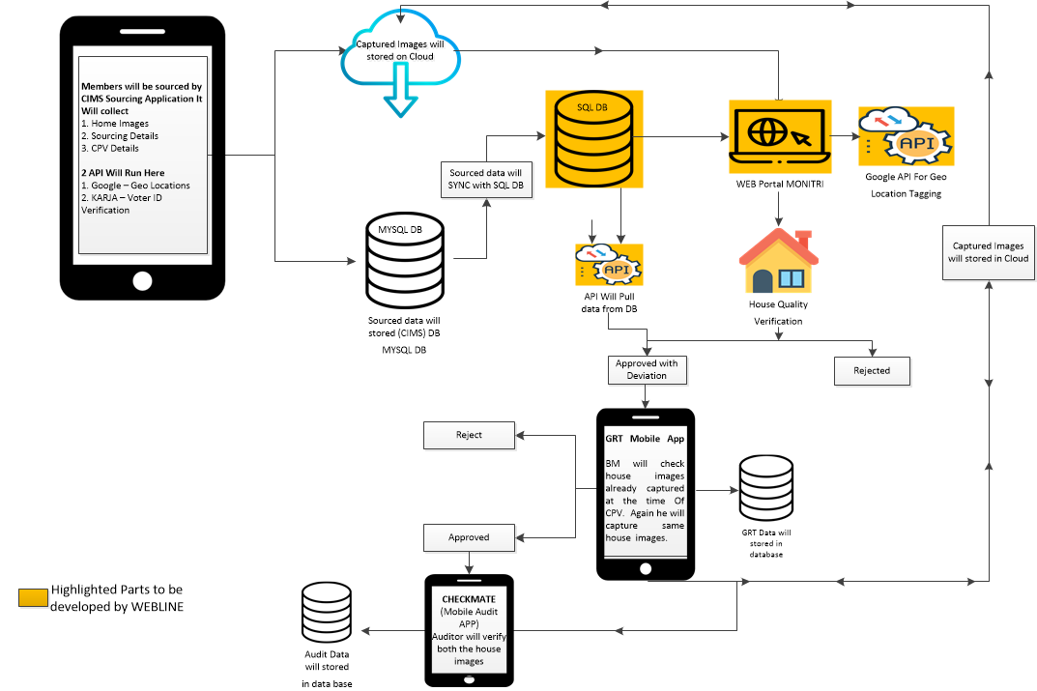

AOCPV Questions: (these will be filled in the sourcing mobile application)

Question | Option 1 | Option 2 | Option 3 | Option 4 | Option 5
Other MFI Active A/Cs | Prefilled
No. of Active A/Cs | Prefilled
Loan O/S | Prefilled
Approval Amount | Prefilled
Phone Number | Prefilled
Two-wheeler at home (optional registeration no. input field) | Yes | No
Own agricultural Land | Yes | No
Own livestock | Goat | Chicken | Cow | Pig | None
Residential Type | Owned | Rented
Children Studying | Yes | No
Source of Income | Agriculture | Business | Salary | Pension | Rental Income
Nominee’s Phone Number
Aadhar linked contact number
Secondary Proof ID

BM- customer rejection reasons:
SR. | Reason
1 | Address Mis-match
2 | Distance from center beyond limit
3 | Delay in Process
4 | Blood Relatives
5 | Ring Leader
6 | Ghost Loan
7 | Fake KYC

Credit Manager- customer rejection reasons:
SR. | Reason
1 | Address differs from KYC/ Mis-match
2 | Fake Documents
3 | Loan Criteria not Met
4 | Ghost Loan/ Ring Leader
5 | More than 2 relatives in the center
6 | Insufficient Income levels to service the loan
7 | Rental Premise <1 year vintage
8 | Same house as an existing member
9 | Location (pin-code) is distant from other members

02. Screens / MONITRI Website
login screen
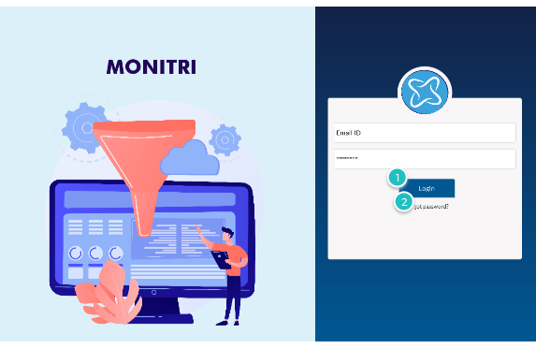

Interactions

1 | on Click: goes to 'Home Page'
2 | on Click: goes to 'Forgot Password'

02. Screens / MONITRI Website
Forgot Password
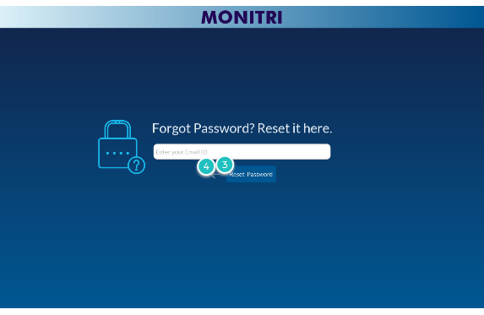

Interactions

3 | on Click: goes to 'Reset Password'
4 | on Click: goes to 'login screen'

02. Screens / MONITRI Website
Reset Password
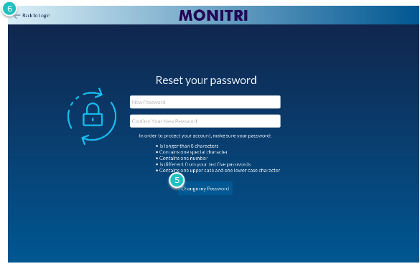

Interactions

5 | on Click: goes to 'login screen'
6 | on Click: goes to 'login screen'

02. Screens / MONITRI Website
Home Page
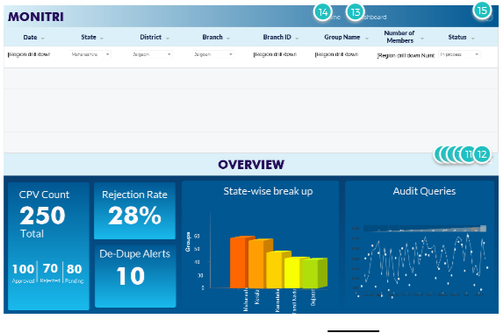

Interactions

13 | on Click: goes to 'Dashboard Screen'
14 | on Click: goes to 'Home Page'
15 | on Click: goes to 'login screen'

- Main screen- members will be seen on real time basis- when cleared from sourcing application.
- Drill down options to be given.
- Clicking on one group name will navigate to group details screen.
- Dashboard will give complete overview of CPV pipeline- drilldown options available on date/BC/State/Branch

02. Screens / MONITRI Website
Group Page
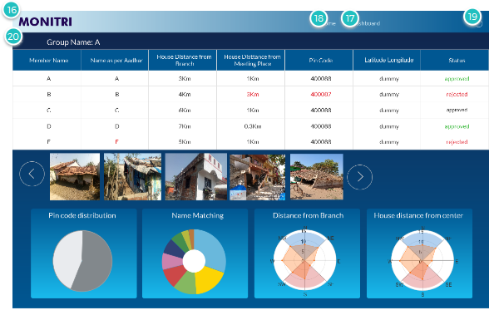

Interactions

16 | on Click: goes to 'Member Screen'
17 | on Click: goes to 'Dashboard Screen'
18 | on Click: goes to 'Home Page'
19 | on Click: goes to 'login screen'
20 | on Click: goes to 'Home Page'

- All group details will be visible in a snapshot- any information not matching with parameters set (e.g. pin code, distance) will be displayed in red.
- All member house images will be shown for a quick view. House matching to be done against- other members in the group, house images in our database.
- Clicking on one member will navigate to the members’ page.
- Dashboard will give complete overview of the group- distance, pin code distribution, etc.
- Accept/Reject status can be changed on this screen

02. Screens / MONITRI Website
Member Screen
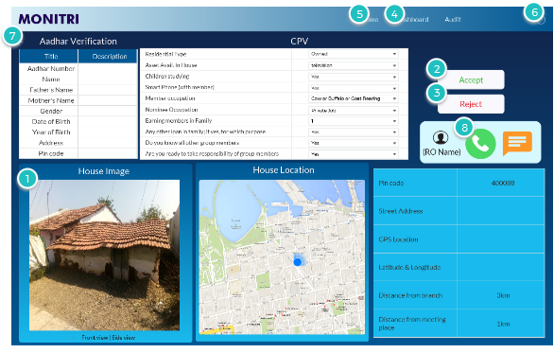

Interactions

1 | on Click: goes to 'Member house click'
2 | on Click: goes to 'Group Page'
3 | on Click: goes to 'Group Page'
4 | on Click: goes to 'Dashboard Screen'
5 | on Click: goes to 'Home Page'
6 | on Click: goes to 'login screen'
7 | on Click: goes to 'Group Page'

- Members details will be visible in detail- any information not matching with parameters set (e.g. pin code, distance) will be displayed in red.
- Member house image will be shown in front and side view.
- Aadhar card details and CPV answers will be displayed along with exact location details.
- Accept/Reject of member to be done here. Accepted members will be fetched into GRT application.
- Credit official should be able to contact field officer via live messaging an d call functionality

02. Screens / MONITRI Website
Member house click
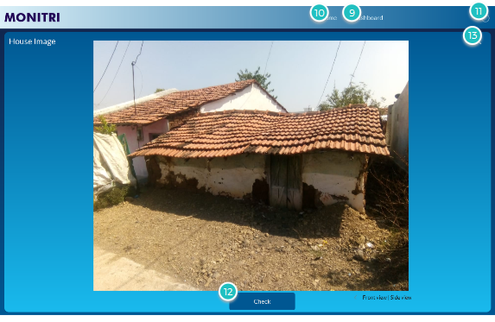

Interactions

9 | on Click: goes to 'Dashboard Screen'
10 | on Click: goes to 'Home Page'
11 | on Click: goes to 'login screen'
12 | on Click: goes to 'Member House Check'
13 | on Click: goes to 'Member Screen'

- On clicking check, all the houses captured within 100 meters will pop up. The house picture will be verified against other house pictures.

02. Screens / MONITRI Website

Member House Check
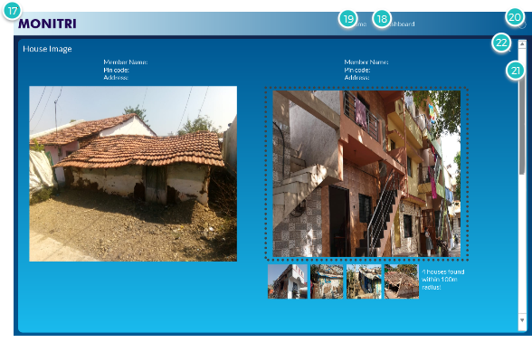

Interactions

17 | on Click: goes to 'Dashboard Screen'
18 | on Click: goes to 'Dashboard Screen'
19 | on Click: goes to 'Home Page'
20 | on Click: goes to 'login screen'
22 | on Click: goes to 'Member house click'

02. Screens / Monitri Website
RO message screen
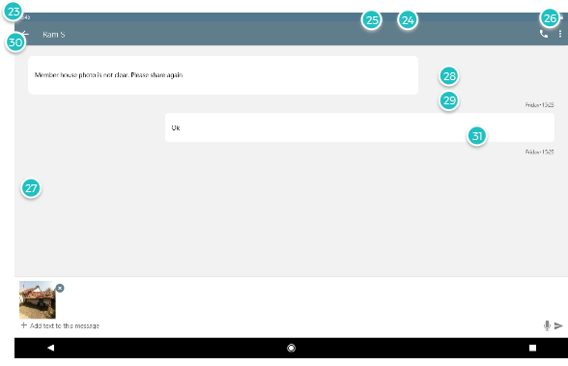

Interactions

23 | on Click: goes to 'Dashboard Screen'
24 | on Click: goes to 'Dashboard Screen'
25 | on Click: goes to 'Home Page'
26 | on Click: goes to 'login screen'
27 | on Click: goes to 'Member house click'
28 | on Click: goes to 'Group Page'
29 | on Click: goes to 'Group Page'
30 | on Click: goes to 'Group Page'

02. Screens / MONITRI Website
Dashboard Screen
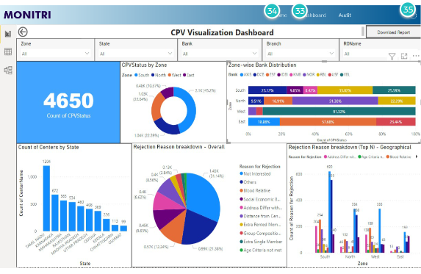

Interactions

33 | on Click: goes to 'Dashboard Screen'
34 | on Click: goes to 'Home Page'
35 | on Click: goes to 'login screen'

- Complete overview of the CPV process to be displayed here along with downloadable excel files.
- CPV count (based on date filter)- and no. of ‘accepted’, ‘rejection’, ‘no action taken’ cases.
- CPV status as per zone.
- CPV status as per state.
- BC wise CPV distribution
- Rejection reason breakdown-overall
- Rejection reason breakdown-as per zone

02. Screens / MONITRI Mobile Application

- Post CGT, approved members of a group will be displayed in Monitri BMCPV application.
- BM must schedule CPV date and time via scheduler option in the second tab. The selected schdule will be highlighted in the homepage and reflect in the schedule screen of the credit analyst.
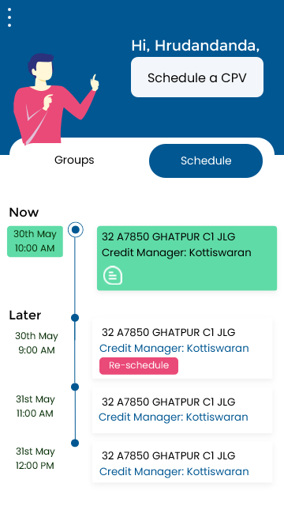
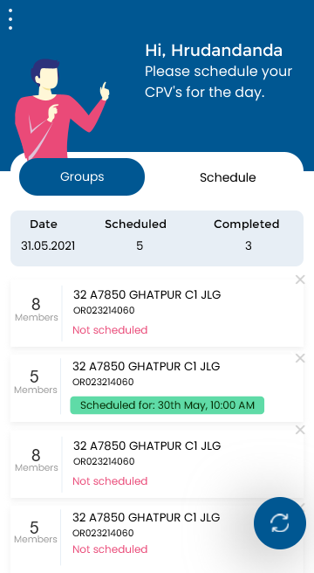

04. Screens / MONITRI Mobile Application

- Only post scheduling a group, BM can commence CPV. After selecting a scheduled group, BM can select any member and begin.
- BM will be able to view basic customer details filled by RO in the sourcing application
- In the second slide, BM will be able to view credit history of the customer. Member can be rejected by the BM if evaluation criteria is not met.
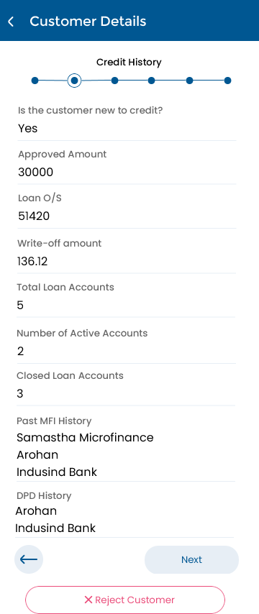
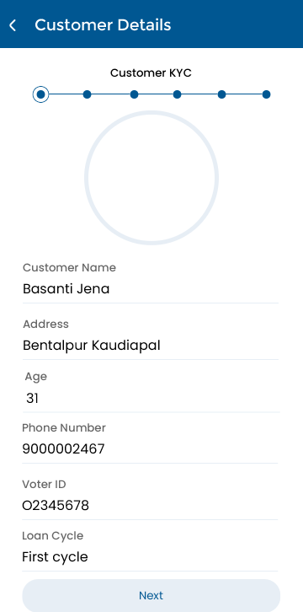

04. Screens / MONITRI Mobile Application

- In slide 3, BM has to enter financial details about the customer that will help understand their average incomes and expenditures.
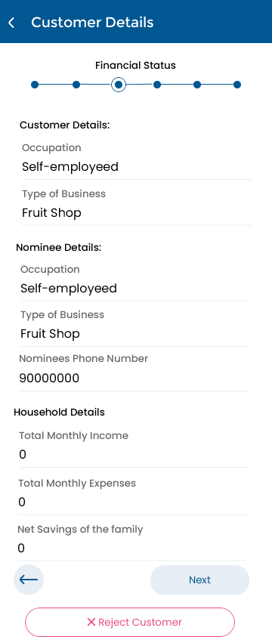

04. Screens / MONITRI Mobile Application

- In slide 4, BM has to enter assets owned by customers.

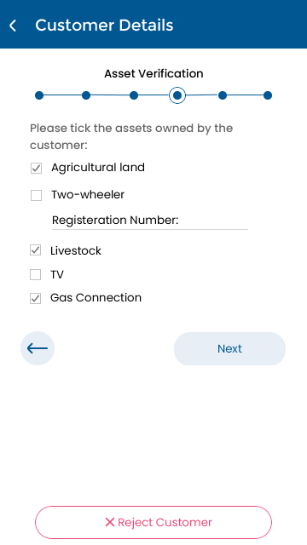

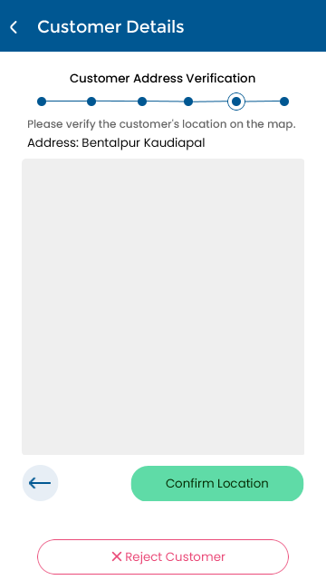
- Lastly, the BM needs to geo-tag the members house location and capture 3 house images of the customer- clearly capturing the assets owned by the customer.
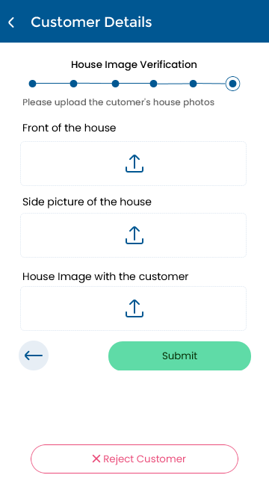

04. Screens / MONITRI Mobile Application

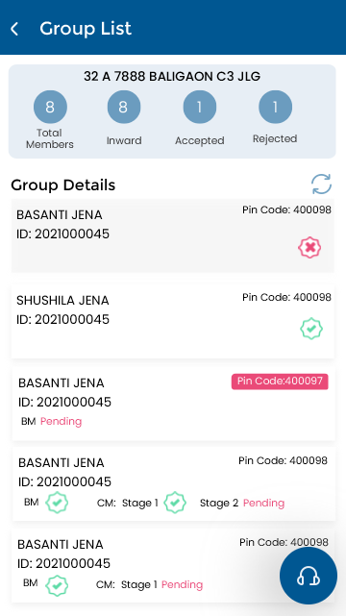
- As customer details are submitted, credit analyst through the web portal will verify and approve/reject the customer on the basis of established parameters. The BM will get real time updates on the same.

- Once action has been taken on all members on the group (accept or reject)- the BM will select a centre meeting place for the group. Credit analyst will evaluate member distance from centre meeting place and will give a final approval. The approved members will be pushed into GRT application.

