Insura- Business Requirement:

Purpose: Digitizing the process currently used to process insurance claims. The application will enable:
- Immediate intimation of claim through mobile application.
- Instant check of uploaded documents, and features to edit, process documents uploaded in field.
- Interaction between Insurance team at HO and branch via document discrepancy notification.
- Intimation to customer/nominee about claim intimation
- Live status of claim available to branch

Current Process Vs. Proposed Process
Current Process | Proposed Process
Death/Hospi Cash Intimation is done via mail | Dedicated mobile application to enter claim intimation details where member details will auto-populated. Instant intimation with the click of a button.
Intimation report is collated and sent to bank partner. | Intimation report will be automated- with respect to bank and date filter.
Documents / any discrepancy in them is sent back and forth | Direct upload and reupload from mobile application and instant Quality Check- QC screen- to upload insurance documents
No live status available to branch staff for claim status | Live status update available to branch staff
Documents post QC check are uploaded manually in SFTP folder | Auto-upload of documents into bank specific SFTP folder post QC check + upload of outstanding amounts along with report in required format.

Users
User | Functions available
Relationship Officer (RO) | - Dashboard view (3 slides) relating to branch  - Adding claim intimation (for death and hospi-cash)  - Uploading claim documents mapped to them  - Re-uploading discrepancy documents mapped to them  - Viewing live customer status in dashboard for all claims pertaining to the branch.
Branch Manager (BM) | - Dashboard view (3 slides) relating to branch  - Adding claim intimation (for death and hospi-cash)  - Uploading claim documents mapped to them  - Re-uploading discrepancy documents mapped to them  - Viewing live customer status in dashboard for all claims pertaining to the branch.  - Re-assigning claim for all staff in the branch
Insurance Team | - Home page which will give a general overview of all claims, and status- filter option available  - QC (main page)which will allow them to view list of all claims available for QC  - QC Screen- which will allow them to download, print, upload, edit (text and file),- and send re-quired documents for reupload.  - Report download and upload options: intimation report download, outstanding report- download and upload, master report- download and upload
Admin | - User creation and mapping  - Uploading member and center data  - Report download and upload options: intimation report download, outstanding report download, status report-download and update, MIS reports, SFTP transfer

Applications in Use
- Mobile Application: To be used by Relationship Officers and Branch Managers
- Web Application: To be used by Insurance team and Admin

General Process flow for death claim:
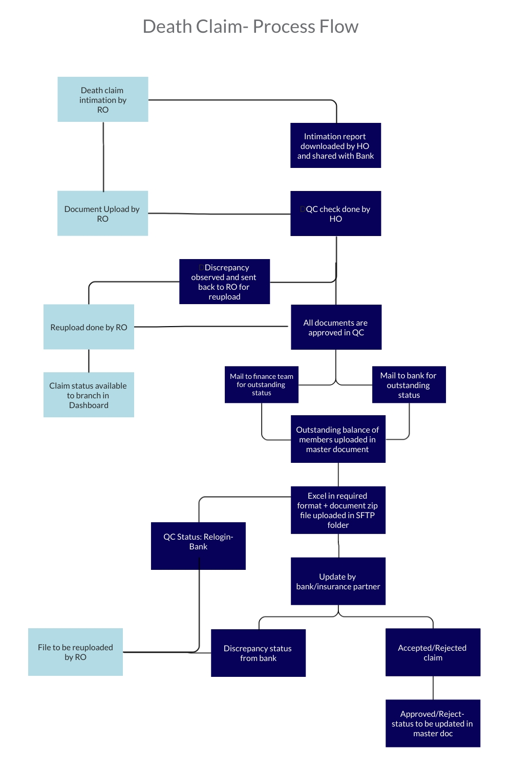

Death Claim Process, Bank Wise:

BC Bank | Step 1 | Step 2 | Step 3 | Step 4 | Field 5
RBL | Intimation report to bank is sent | Outstanding request is sent to RBL Bank | After outstanding amount upload, documents + excel format are uploaded in bank SFTP folder. | Receive final status from bank | Update final status in master document
YBL KLI |  | Outstanding request is sent to Collection Team (Jaikanth) | After outstanding amount upload, documents + excel format are uploaded in bank SFTP folder. | Receive final status from bank | Update final status in master document
YBL (Bajaj, Max) applicable to all cases disbursed between April 2019-Feb 2021 |  | NA | documents + excel format are uploaded in bank SFTP folder. | Receive final status from bank | Update final status in master document
KMBL |  | Outstanding request is sent to Collection Team (Jaikanth) | After outstanding amount upload, documents + excel format are uploaded in bank SFTP folder. | Receive final status from bank | Update final status in master document
Axis |  | Outstanding request is sent to Axis Bank | After outstanding amount upload, documents + excel format are uploaded in bank SFTP folder. | Receive final status from bank | Update final status in master document
DCB |  | Outstanding request is sent to Collection Team (Jaikanth) | After outstanding amount upload, documents + excel format are uploaded in bank SFTP folder. | Receive final status from bank | Update final status in master document
IDBI |  | Outstanding request is sent to Collection Team (Jaikanth) | After outstanding amount upload, documents + excel format are uploaded in bank SFTP folder. | Receive final status from bank | Update final status in master document
USFB |  | Outstanding request is sent to USFB Bank | After outstanding amount upload, documents + excel format are uploaded in bank SFTP folder. | Receive final status from bank | Update final status in master document
Fedfina |  | Outstanding request is sent to Fedfina Bank | After outstanding amount upload, documents + excel format are uploaded in bank SFTP folder. | Receive final status from bank | Update final status in master document
IDFC |  | Outstanding request is sent to Collection Team (Jaikanth) | After outstanding amount upload, documents + excel format are uploaded in bank SFTP folder. | Receive final status from bank | Update final status in master document
NARC |  | Outstanding request is sent to Collection Team (Jaikanth) | After outstanding amount upload, documents + excel format are uploaded in bank SFTP folder. | Receive final status from bank | Update final status in master document
FSFB (have to check)
ESFB |  | NA | documents + excel format are uploaded in bank SFTP folder. | Receive final status from bank | Update final status in master document

Mobile Application:

Login
- Relationship Officers (Ros) and Branch Managers (BMs) will be given an individual login as per their employee ID- but common data for the branch will be reflected in the mobile application.
- While the field staff can only enter claim/upload documents from their employee ID, overall claims pertaining to branch will be visible to them in Claim Intimation (offline), Document Upload, Discrepancy and Dashboard tab.
- Password policy will be in line with the standard policy followed by the organisation:
- Minimum 8 characters
- 1 upper-case letter
- 1 lower-case letter
- 1 special character
- Be different from your last 5 passwords
- Forgot Password
-Click on ‘forgot password’- and enter phone number.
- They will receive OTP with reset password link
- Enter OTP and reset password (new password + reset password)
(Number taken from CIMS-CUG)

Slider Data
- After logging into the application, 3 slider cards will be reflected claim data for the branch. They will display:
- Claims intimated by the branch till date
- Documents Uploaded by the branch till date
- Discrepancy alerts raised for the branch till date

Homepage Tabs
Homepage will contain four tabs:
- Claim Intimation
- Document Upload
- Discrepancy Alerts
- Dashboard
- Re-assign claims (only for Branch Manager (BM designation)
- Download Sample Form

Pending tasks in any of the tabs will be reflected with a circle notification on the tab.

Download sample Form
A download Icon/option need to be added – On licking it a PDF needs to get downloaded – It will have a sample of “How to fill the form” details, where newly joined RO can able to understand the form by himself.

Claim Intimation Tab
Fields to be filled by RO for death intimation:

BC Bank | Field 1 | Field 2 | Field 3 | Field 4 | Field 5 | Field 6 | Field 7 | Field 8
RBL | LAN-  Type: | Group Name (auto-populated) | Deceased Person  (drop down- Member/Nominee) | Date of Death  (Date Picker) | Date of Intimation (Date Picker) | Alive person’s mobile no  (phone number validation) | Name of spouse  (Text)
YBL (Bajaj and Max) | LAN-  Type: | Group Name (auto-populated) | Deceased Person  (drop down- Member/Nominee) | Date of Death  (Date Picker) | Date of Intimation (Date Picker) | Alive person’s mobile no  (phone number validation) | Insurance Partner (Text – Auto-Populated) | Member ID  (member/nominee)
YBL KLI | LAN-  Type: | Group Name (auto-populated) | Deceased Person  (drop down- Member/Nominee) | Date of Death  (Date Picker) | Date of Intimation (Date Picker) | Alive person’s mobile no  (phone number validation) | Insurance Partner (Text – Auto-Populated )
KMBL | LAN-  Type: | Group Name (auto-populated) | Deceased Person  (drop down- Member/Nominee) | Date of Death  (Date Picker) | Date of Intimation (Date Picker) | Alive person’s mobile no  (phone number validation)
Axis | LAN-  Type: | Group Name (auto-populated) | Deceased Person  (drop down- Member/Nominee) | Date of Death  (Date Picker) | Date of Intimation (Date Picker) | Alive person’s mobile no  (phone number validation)
DCB | LAN-  Type: | Group Name (auto-populated) | Deceased Person  (drop down- Member/Nominee) | Date of Death  (Date Picker) | Date of Intimation (Date Picker) | Alive person’s mobile no  (phone number validation)
IDBI | LAN-  Type: | Group Name (auto-populated) | Deceased Person  (drop down- Member/Nominee) | Date of Death  (Date Picker) | Date of Intimation (Date Picker) | Alive person’s mobile no  (phone number validation)
USFB
Fedfina | LAN-  Type: | Group Name (auto-populated) | Deceased Person  (drop down- Member/Nominee) | Date of Death  (Date Picker) | Date of Intimation (Date Picker) | Alive person’s mobile no  (phone number validation)
IDFC | LAN-  Type: | Group Name (auto-populated) | Deceased Person  (drop down- Member/Nominee) | Date of Death  (Date Picker) | Date of Intimation (Date Picker) | Alive person’s mobile no  (phone number validation)
NARC | LAN-  Type: | Group Name (auto-populated) | Deceased Person  (drop down- Member/Nominee) | Date of Death  (Date Picker) | Date of Intimation (Date Picker) | Alive person’s mobile no  (phone number validation)
FSFB
ESFB | LAN-  Type: | Group Name (auto-populated) | Deceased Person  (drop down- Member/Nominee) | Date of Death  (Date Picker) | Date of Intimation (Date Picker) | Alive person’s mobile no  (phone number validation)

Submit Options:
The user has two option to submit intimation- either ‘Submit’- which will instantly submit the intimation, or ‘Upload Later’- which will save the intimation in the intimation tab. On reaching a place with sufficient network, the user can click ‘Upload Now’ button to upload the file.
Submit validation:
- Duplication to be checked: for this, LAN and deceased person (member/nominee) has to be cross verified before file gets submitted.
- In case of duplicate entry, pop up to be reflected- “Claim is already in process”.
- Claim should be filed within 2 years from date of disbursement. In this case- pop up “Claim tenure expired.”

Upon Clicking Submit:
- Email to be sent to branch:
An insurance claim has been registered against <member/nominee> <name of deceased> of <branch name> on <date> by <RO name>. Please fill the insurance form, get it signed by customer/nominee and upload it on Insura mobile application.
Please do not reply, this is an auto-generated reply.
In case of any queries, please contact: <respective email as per insurance handler>

- SMS to be sent on alive person’s phone no in regional language:

Upload Document Tab:
List of Documents to be uploaded:
S.R. | Document Type (header) | No. of files to be uploaded | Field 2 | Field 3 | Field 4 | Field 5
1 | Insurance forms* | 4 (max 4) | Insurance form 2 | Insurance form 3
2 | Death Certificate* | 1
3 | Member KYC* | 2 (front and back)
4 | Nominee KYC* | 2 (front and back)
5 | Bank Passbook* | 1 | Bank Name | Account Holder’s Name | Account Number | IFSC Code
6 | Loan Card | 1
7 | Certificate of Insurance | 1
8 | Any Other Document | 1

Those marked * are compulsory to upload

Insurance Forms:
BC Bank | No of Forms | Form Name
RBL | 2 | Claim Intimation form, Authentication form
YBL KLI | 1 | Claim Intimation form,
YBL (Bajaj&Max) | 2 | Claim Intimation form, Vernacular Declaration Form
IDBI | 1 | Claim Intimation form,
KMBL | 1 | Claim Intimation form,
DCB | 1 | Claim Intimation form,
Axis | 4 | Claim Intimation form, Declaration of death, Customer Consent, JLG Loan Application
USFB | 1 | Claim Intimation form,
Fedfina | 1 | Claim Intimation form,
IDFC | 1 | Claim Intimation form,
Nor Arc | 1 | Claim Intimation form,
FSFB | 0 | Not Applicable
ESFB | 0 | No Forms

Submit Options:
The user has two option to submit documents- either ‘Submit’- which will instantly submit the documents, or ‘Upload Later’- which will save the documents in the ‘upload documents’ tab. On reaching a place with sufficient network, the user can click ‘Upload Now’ button to upload the file.

Discrepancy Tab:

-Claims which have been flagged for discrepancy by Insurance team at HO will reflect in this tab.
- Discrepancy page for a member will reflect the documents that have to be reuploaded by the RO/BM (user) and the reason for re-upload.

Submit Options:
The user has two option to submit documents- either ‘Submit’- which will instantly submit the documents, or ‘Upload Later’- which will save the documents in the ‘discrepancy alerts’ tab. On reaching a place with sufficient network, the user can click ‘Upload Now’ button to upload the file.

Notification
Notification intimation via push notification to be sent to user in case of discrepancy lodged by Insurance team for a claim.

Dashboard
Dashboard will give real time update about the status of claim.
Status will directly be linked to the status update made in the web portal:
Status in web portal (backend) | Status in Dashboard
Pending (Fresh / not started to check) | Documents Submitted: QC Pending
Cleared (No Discrepancy) | Documents Submitted: QC Cleared
Discrepancy (go to RO TAB) | Documents Submitted: QC Query
Re-login: (RO Cleared & Submit) | Documents Submitted: QC Pending
Bank Query | Documents Submitted: Bank Query
Bank Re-login : | Documents Submitted: QC Pending
WIP at NOCPL | Documents Submitted: WIP at NOCPL
WIP at Insurance Partner | Documents Submitted: Submitted to Insurance Partner
Reject by Insurance partner | Documents Submitted: Reject by Insurance partner
NOCPL has to settle | Documents Submitted: NOCPL has to settle
Claim Settled | Documents Submitted: Claim Settled

Re-Assign Claims (available only to BMs)
This screen will allow Branch Manager to re-map current (not settled) claims pertaining to the branch. A user can only upload/re-upload documents to claims assigned to them. Clicking on a claim will reflect current Assignee + give BM an option to re-assign the claim to any of the branch users (including BM).
Web Application:

Main functions of the web application:
-Collating data pertaining to members, disbursement and data entered from field (insura mobile application) to generate reports
- Instant checking of documents, and editing documents through QC screen
- Downloading relevant reports and manual updation of specified fields in the report.
- Transfer of documents to SFTP folder.

Homepage:
- Dashboard will be created as per MIS report

QC Screen:
- Dashboard screen with claim details
  - QC Dashborad screen should have 3 filters (Listed below- with Multiple selection)
  - QC “Cleared” claims should not reflect in status.
- BC Bank
- Date (Document received date)
- Status

S No | Document Received Date | BC Name | Branch Name | CenterName | Loan Account No | Policy No / Claim No | Member Name | Deceased Person | Status

- Status of the claims will be:
Pending (Fresh / not started to check)
Cleared (No Discrepancy)
Discrepancy (go to mobile app for reupload)
Re-login (RO Cleared & Submit)
Bank Query (after cleared, drop down option for discrepancy: bank to appear)-> changing this status will allow re-QC
Bank Re-login (when entry has been made from mobile application for Discrepancy: Bank, this status will be reflected)

Bank Re-login documents needs to be stored separately. Those document needs to be needs to be submitted to bank/insurance partner after QC.
QC Screen- Member Page:
QC screen section wise:

Member detail section will reflect the following details of the member:
- Member Name (populated from backend)
- LAN No. (populated from backend)
- Policy No (populated from Database)
- Nominee Name (populated from backend)
- Deceased Person (Member/Nominee)
- Name of the Deceased Person (Member Name/ Nominee Name) (populated from backend)
- Date of Death (populated from field)
- Bank Name (populated from field)
- Bank Account Number (populated from field)
- Bank Account Holder’s name (populated from field)
- IFSC Code (populated from field)

These fields will be populated from the mobile device. Insurance holder has the option to edit the text.

Under member details, icons will reflect all the documents uploaded. Clicking on the tab should reflect the document on the left side of the screen (QC screen)

Under each document icon,
S.R. | Document Type (header) | Drop Down Remarks for Discrepancy
1 | Insurance form 1 | - Form is incomplete  - Wrong data has been filled  - Nominee sign is missing  - BM sign & seal is missing  - Image is not clear
2 | Insurance form 2 | - Form is incomplete  - Wrong data has been filled  - Only nominee thumb impression is required (Not Signature)  - In Date Column-fill Disbursement Date  - BM sign & seal is missing  - Image is not clear
3 | Insurance form 3
4 | Death Certificate | - Name mismatch with Aadhar Card (Need Rs100 Affidavit)  - Wrong Gender Mentioned (Need Revised Death Certificate)  - Need Verification Signature in Death Certificate copy  - Image Not clear
5 | Member KYC | - First 8 digits not masked  - Image Not clear
6 | Nominee KYC | - First 8 digits not masked  - Image Not clear
7 | Bank Passbook | - Need colour Pass Book Copy  - Printed Details Not Clear  - Old IFSC Printer (Need new IFSC - Bank Merged)  - Image Not Clear
8 | Loan Card | - Image Not clear
9 | Certificate of Insurance | - Image Not clear
10 | Any Other Document | - Image Not clear

Insurance Officer can select the reason for discrepancy under each document (multiple options can be selected)
If there are 0 discrepancy’s and submit is clicked- claim will move to next stage (where outstanding balance has to be updated)

If there is discrepancy in this screen, this intimation will be submitted to the field officer’s mobile application with documents to be reuploaded along with reason for discrepancy.

Following functionalities will be available to edit the document (in case discrepancy can be resolved by the insurance team itself)-
- Download functionality
- Print functionality
- Re-upload file functionality
- Crop functionality
- Add text function
- Add black-fill rectangle
Option to save (update) edited file will be available.

Report Page:
The following reports will be made available:
- Intimation Report: Whenever an intimation is initiated from field. This report will be generated as per BC wise format in the excel sheet shared. Filter as per date, zone, state, area, branch and status will be available.

- Outstanding Report: This report will be generate as per BC wise format shared. Claims are mapped date wise- Date of clearing QC/ Uploading Outstanding claim will be considered as final date (for filter purpose)

- Status Update: This report will be comprehensive (no BC wise segregation)- updates here will be mapped via LAN number. Outstanding amount and claim status can be changed through this report. User has an option to download the report template and upload the document to update changed status and outstanding figure.

- MIS- One comprehensive report will be available for all BC’s , plus individual reports BC wise. Filter as per date, zone, state, area, branch and status will be available.

- Update to SFTP: Once claim has cleared QC + Outstanding amount for the same claim has been updated- the file should appear in this folder for direct upload to Bank SFTP. This will be segregated BC wise.

  - Bank Relogin – (Separate TAB under update to SFTP) Once Bank Relogin is QC cleared - the file should appear in this folder for direct upload to Bank SFTP. This will be segregated BC wise.
  - For all BC only relogin files has to be downloaded (Except YBL Bajaj&Max)
  - For YBL Bajaj&Max full set of docs has to be downloaded (Old + Relogin files).
MIS Report:
SR No – System has to create / tag a unique ID to each claim that login.
- SR No is a combination of bank Name, Month&Year of claim Login(mmyy), Number series.
- Number series need to be revised every month, it has to restart from “0001”

Bank | Login Month& Year | Number Series | SR No
RBL | 0821 | 0001 | RBL08210001
YBLK | 0821 | 0001 | YBLK08210001
YBLB | 0821 | 0001 | YBLB08210001
IDBI | 0821 | 0001 | IDBI08210001
KMBL | 0821 | 0001 | KMBL08210001
DCB | 0821 | 0001 | DCB08210001
Axis | 0821 | 0001 | Axis08210001
USFB | 0821 | 0001 | USFB08210001
Fed | 0821 | 0001 | Fed08210001
IDFC | 0821 | 0001 | IDFC08210001
NARC | 0821 | 0001 | NARC08210001
FSFB | 0821 | 0001 | FSFB08210001
ESFB | 0821 | 0001 | ESFB08210001

General Process flow for Hospi Cash claim:

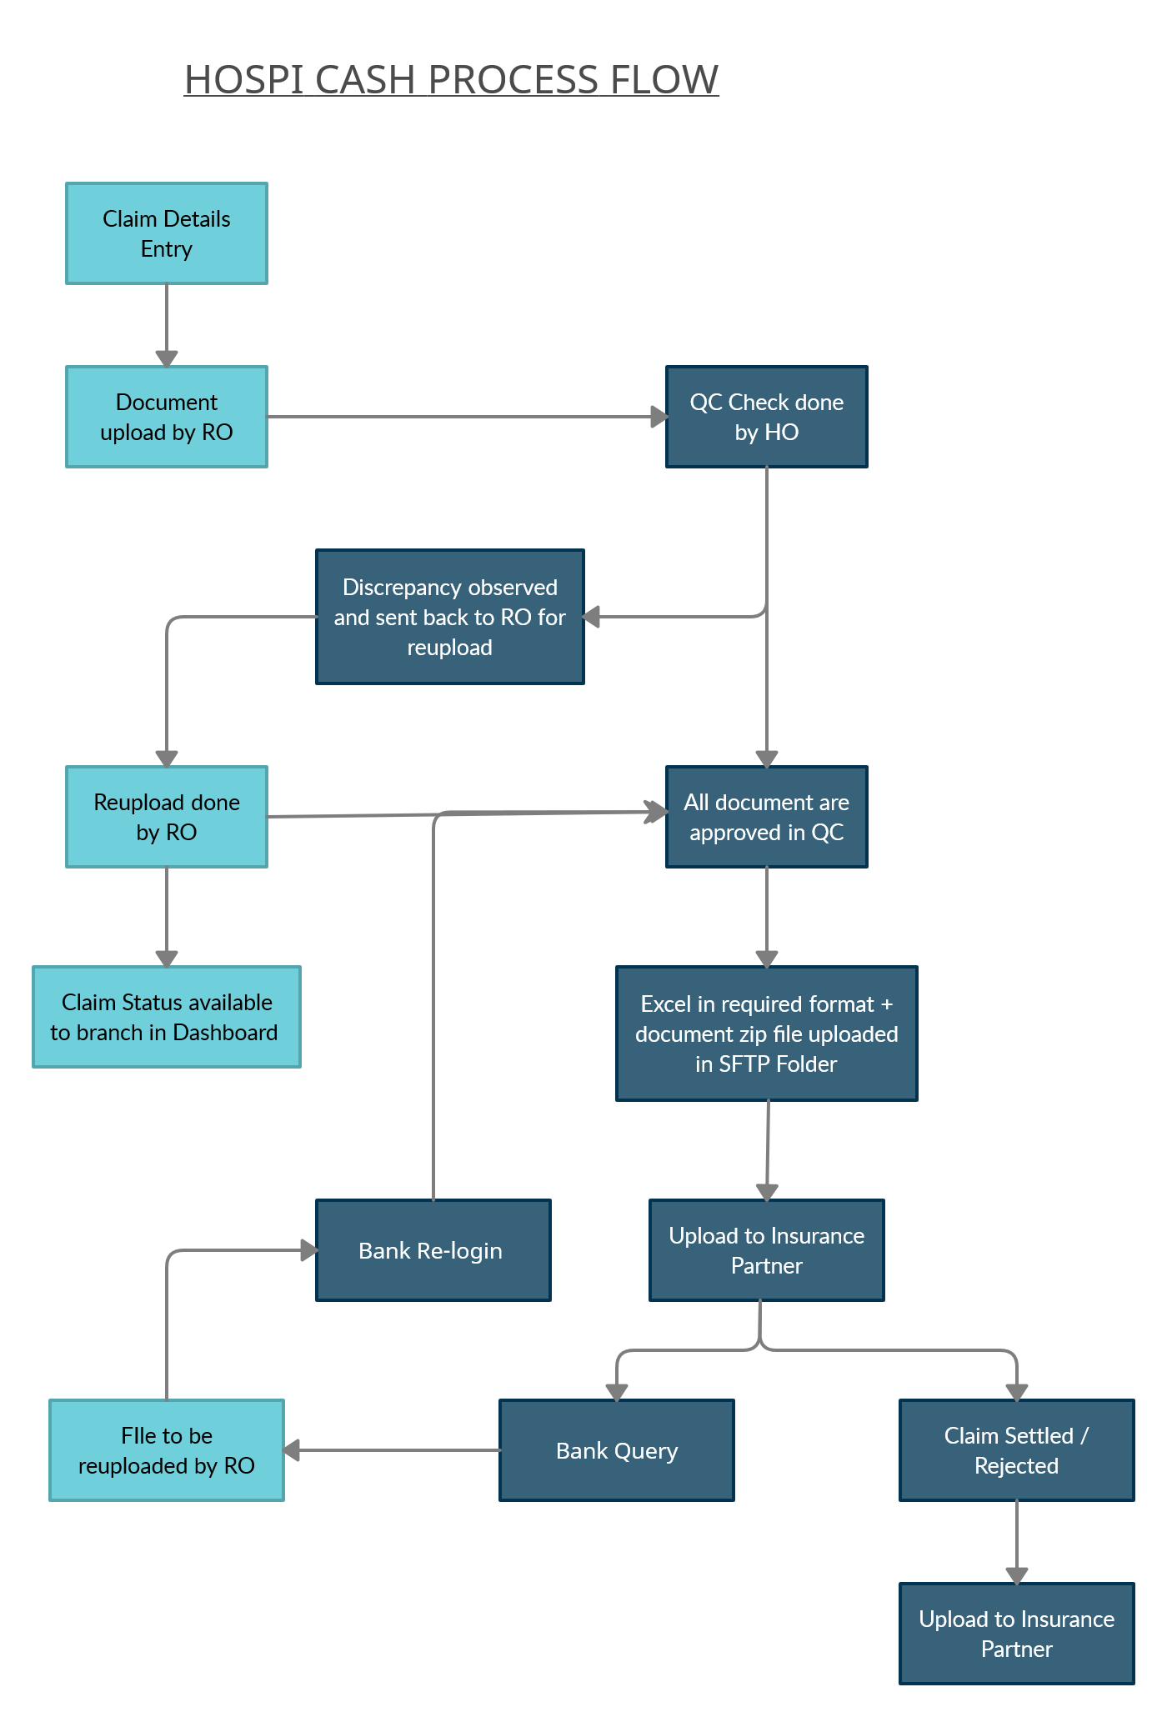

Death Claim Process, Bank Wise:
BC Bank | Step 1 | Step 2 | Step 3 | Step 4 | Field 5
RBL | Intimation report Submitted by RO | NA | After document cleared QC, excel format + Documents are uploaded in bank/Insurance Partner. | Receive final status from bank | Update final status in master document
YBL | Intimation report Submitted by RO | NA | After document cleared QC, excel format + Documents are uploaded in bank/Insurance Partner | Receive final status from bank | Update final status in master document
KMBL | Intimation report Submitted by RO | NA | After document cleared QC, excel format + Documents are uploaded in bank/Insurance Partner . | Receive final status from bank | Update final status in master document

Claim Intimation Tab
Fields to be filled by RO for death intimation:
BC Bank | Field 1 | Field 2 | Field 3 | Field 4 | Field 5 | Field 6 | Filed 7 | Field 8
YBL | LAN (Type) | Group Name (auto-populated) | Admitted Person  (drop down- Member/Nominee) | Date of Admission (Date Picker) | Date of Discharge (Date Picker) | Alive person’s mobile no  (phone number validation) | Hospital Name (Type) | Hospital Pincode (Type)
RBL | LAN (Type) | Group Name (auto-populated) | Admitted Person  (drop down- Member/Nominee) | Date of Admission (Date Picker) | Date of Discharge (Date Picker) | Alive person’s mobile no  (phone number validation)
RBL | LAN (Type) | Group Name (auto-populated) | Admitted Person  (drop down- Member/Nominee) | Date of Admission (Date Picker) | Date of Discharge (Date Picker) | Alive person’s mobile no  (phone number validation)

Submit validation:
- Duplication to be checked: for this, LAN, admitted person & Date of admission (member/nominee) has to be cross verified before file gets submitted.
- In case of duplicate entry, pop up to be reflected- “Claim is already in process”.
- Claim should be filed within 1 years from date of disbursement. In this case- pop up “Claim tenure expired.”
- Upload Document Tab:
- List of Documents to be uploaded:
S.R. | Document Type (header) | No. of files to be uploaded | Field 2 | Field 3 | Field 4 | Field 5
1 | Insurance forms* | 6 (max 4) | Insurance form 2 | Insurance form 3 | Insurance form 4 | Insurance form 5 | Insurance form 6
2 | Discharge Summary* | 2
3 | Additional Medical Documents* | (Multiple Pages) need to stack with a file
3 | Member KYC* | 1 (front and back)
4 | Nominee KYC* | 1 (front and back)
5 | Bank Passbook* | 1 | Bank Name | Account Holder’s Name | Account Number | IFSC Code
6 | Loan Card | 1
7 | Certificate of Insurance | 1
8 | Any Other Document | 1

- Those marked * are compulsory to upload

- Insurance Forms:
BC Bank | No of Forms | Form Name
RBL | 3 | Claim Intimation form, Authentication form
YBL | 4 | Claim Intimation form,
KMBL | 6 | Claim Intimation form, Vernacular Declaration Form

QC Screen:
- Dashboard screen with claim details
  - QC Dashborad screen should have 3 filters (Listed below- with Multiple selection)
  - QC “Cleared” claims should not reflect in status.
- BC Bank
- Date (Document received date)
- Status

S No | Document Received Date | BC Name | Branch Name | Center Name | Loan Account No | Policy No / Claim No | Member Name | Admitted Person | Status

QC Screen- Member Page:
QC screen section wise:
Member detail section will reflect the following details of the member:
- Member Name (populated from backend)
- LAN No. (populated from backend)
- Policy No (populated from backend)
- Admitted person Name (populated from backend)
- Admitted Person (Member/Nominee)
- Date of Admission (populated from backend)
- Date of Discharge (populated from field)
- Hospital Name (YBL BC) (populated from field)
- Hospital Pincode (populated from field)
- Bank Name (populated from field)
- Bank Account Number (populated from field)
- Bank Account Holder’s name (populated from field)
- IFSC Code (populated from field)

These fields will be populated from the mobile device. Insurance holder has the option to edit the text.

Under member details, icons will reflect all the documents uploaded. Clicking on the tab should reflect the document on the left side of the screen (QC screen)

Under each document icon,
S.R. | Document Type (header) | Drop Down Remarks for Discrepancy
1 | Insurance form 1 | - Form is incomplete  - Wrong data has been filled  - Nominee sign is missing  - BM sign missing  - Image is not clear
2 | Insurance form 2 | - Form is incomplete  - Wrong data has been filled  - Nominee sign is missing  - BM sign missing  - Image is not clear
3 | Insurance form 3 | - Form is incomplete  - Wrong data has been filled  - Nominee sign is missing  - BM sign missing  - Image is not clear
4 | Insurance form 4 | - Form is incomplete  - Wrong data has been filled  - Nominee sign is missing  - BM sign missing  - Image is not clear
5 | Insurance form 5 | - Form is incomplete  - Wrong data has been filled  - Nominee sign is missing  - BM sign missing  - Image is not clear
6 | Insurance form 6 | - Form is incomplete  - Wrong data has been filled  - Nominee sign is missing  - BM sign missing  - Image is not clear
7 | Discharge Summary (1) | - Hospital Name Missing  - Hospital Pincode Missing  - Doctor Seal & Sign Missing  - DOA or DOD Missing  - Name Mismatch in Summary  - Image Not clear
8 | Discharge Summary (1) | - Hospital Name Missing  - Hospital Pincode Missing  - Doctor Seal & Sign Missing  - DOA or DOD Missing  - Name Mismatch in Summary  - Image Not clear
9 | Additional Medical Documents | - Hospital Name Missing  - Hospital Pincode Missing  - Doctor Seal & Sign Missing  - DOA or DOD Missing  - Name Mismatch in Summary  - Image Not clear
9 | Nominee KYC | - First 8 digits not masked  - Image Not clear
10 | Nominee KYC | - First 8 digits not masked  - Image Not clear
11 | Bank Passbook | - Need colour Pass Book Copy  - Printed Details Not Clear  - Old IFSC Printer (Need new IFSC - Bank Merged)  - Image Not Clear
12 | Loan Card | - Image Not clear
13 | Certificate of Insurance | - Image Not clear
14 | Any Other Document | - Image Not clear

MIS Report:
SR No – System has to create / tag a unique ID to each claim that login.
- SR No is a combination of bank Name, Month&Year of claim Login(mmyy), Number series.
- Number series need to be revised every month, it has to restart from “H001”

Bank | Login Month& Year | Number Series | SR No
RBL | 0821 | H0001 | RBL0821H0001
YBL | 0821 | H0001 | YBL0821H0001
KMBL | 0821 | H0001 | KMBL0821H0001

