Monitri Updates + Audit Screen

- Monitri Updates:
- Group page map, display only after center meeting place has been selected.
- Rejection reason by credit analyst to be sent to LOS dashboard (api required)
- Under assets, add:
- Availability of smart phone: Yes/No
- Pre-paid/ Post-paid SIM card (tick one)
- House Owned/ Rented, no. of years of living in the same house ___
- Members with smart phone- member details should be available to download as a separate report.
- Resize option to be there during video calls. User should be able to resize, and move the box around the screen.
- Incoming call notifications should flash (when user is on another call)
- In 150m check- photo is currently getting cropped. Full image should be seen.
- ‘Now’ Column of homepage should reflect no. of members.
- Show no. of members in schedule page.
- Show status ‘pending’, ‘completed’ in schedule page.
- Show no of approved/rejected members in schedule page, besides status.
- Group Calling functionality to be added

- Pre-disbursement audit to be conducted for approved group. Minimum 1 members for approved members between 1-5, minimum 2 members for approved members 6 and up. Questions:
- Has anyone asked you for money to avail this loan?
Answer drop down: 1) Company Employee 2) Center Leader 3) Third Party
- Do you have any complaints against our employee?
Answer drop down: 1) Forced/Mis-selling of Third Party Products 2) Paid Commission to Employee 3) Staff behavioral complaints
- Are you availing this loan for yourself or on behalf of someone else
Answer drop down: For myself/ For someone else
- Member phone number

- Reject from CA side, only these options fixed (can only add from backend)

- Blood Relatives
- Fake Document Produced
- KYC Mismatch
- Poor Living Condition
- Distance Beyond Norms.

Audit Page:
- Completed groups to go into two tabs- Approved, Rejected
- These will be archived into another server (once CA makes the decision). Audit page should be displayed from Archive database only.
- If someone wants to download bulk data for multiple groups, application should facilitate this.
- Groups can be filtered on the basis of:
- Zone
- Bank Partner
- State
- Region
- Branch
- Credit Analyst
- BM
- Relationship Officer

Screen 1- Approved/ Reject Tab

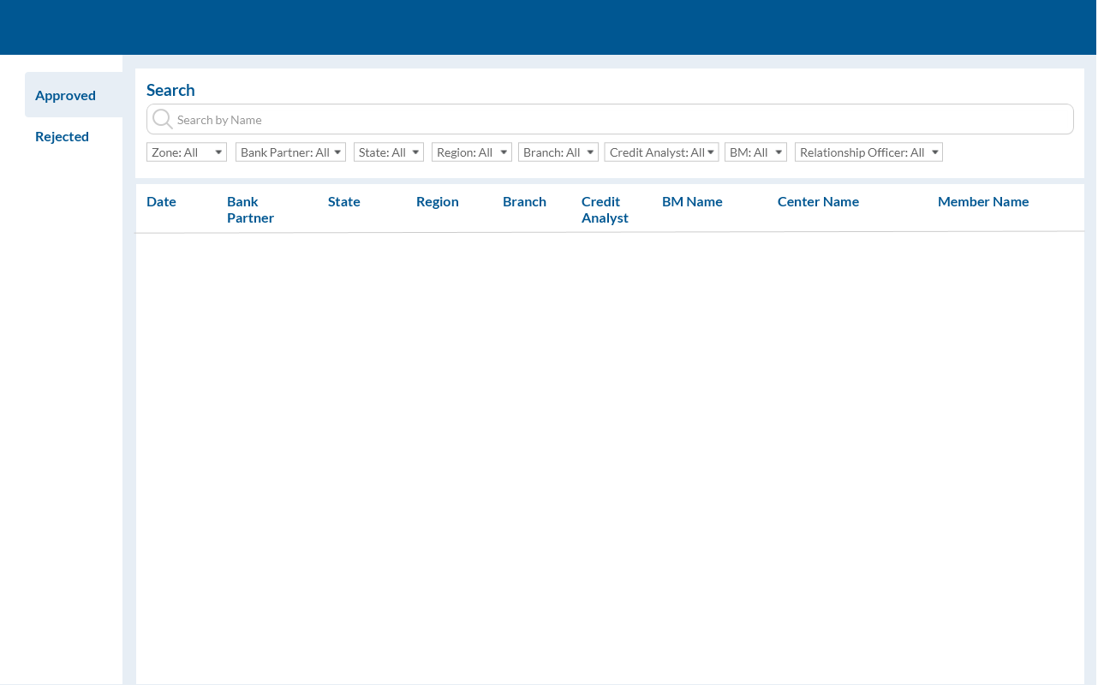
Screen 2- Group Page-which will be the same as Group screen in monitri
Screen 3- Member Page- which will be the same as member screen in monitri
- with option to add Audit related questions, and provide drop downs with answer options
- Submitting the answers should register as a long, mentionining date of the audit.
- Member phone number to be displayed

