Customer Onboarding Application: BRD

Objective:
Creating a customer onboarding journey which is compliant to RBI Micro-credit policy released in March, 22.
Key changes -

A microfinance loan is defined as a collateral-free loan given to a household having annual household income up to ₹3,00,000. For this purpose, the household shall mean an individual family unit, i.e., husband, wife and their unmarried children.
Each RE shall have a board-approved policy regarding the limit on the outflows on account of repayment of monthly loan obligations of a household as a percentage of the monthly household income. This shall be subject to a limit of maximum 50 per cent of the monthly household income.
The computation of loan repayment obligations shall take into account all outstanding loans (collateral-free microfinance loans as well as any other type of collateralized loans) of the household. The outflows capped at 50 per cent of the monthly household income

Basic App Flow
- Group is formed.
- A prospective member is added into the group created
- Family composition is checked- how many earning/dependents
- Member KYC is authentication via EKYC.
- Voter ID/Pan card and basic details of family members are entered
- Bureau check is run for all family members- if all are approved- customer moves into the next bucket-income assessment.
- Basic income and expense details are entered.
- Final bureau check is run which will give tentative approved amount/tenure details
- Now field officer needs to enter additional details like- detailed expenses, social details, asset details, banking details and upload final docs.
- The customer will now move into the queue for CPV.

Mobile Application
User: Field Officers
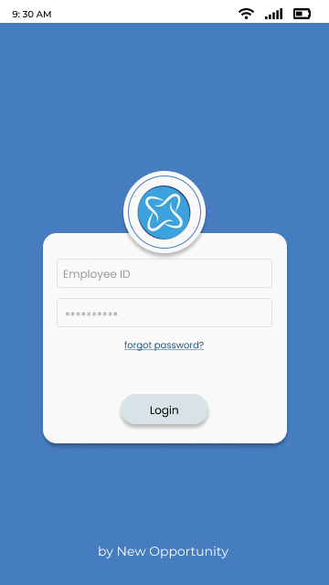

  - User Login
- User will login with employee ID and the (first time) shared password.
- If the user enters the incorrect password for consecutive three times, then user will not be able to login for the next 10 minutes.
- In case the user forgets password, the user has an option to reset it by clicking forgot password button. Upon selecting the forgot password button, user moves on to a new screen where the user must enter his employee ID and an OTP will go to the registered employee mobile number.
- On submitting the correct OTP, user needs to enter the new password, and confirm the password.
- The new password must meet our company password policy:
- Password should contains One Uppercase letter, One Numeric letter and One Symbol (!,@,#,$,%,^,&,*)
- Password Length Should be in minimum 8 characters
- Once the user submits the new password, they are re-directed back to login page. After successful login, user is directed to homepage.

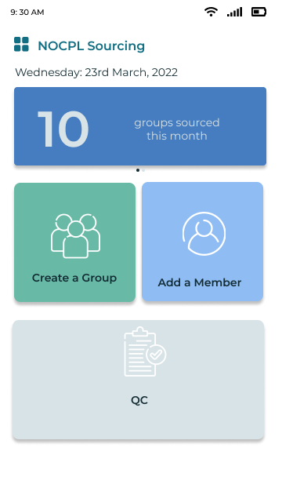
  - Homepage
- Upon logging in, the user is redirected to the homepage.
- The homepage contains
- An option to add potential groups through the ‘create a group’ tab
- A button to add potential members through the ‘add members’ tab
- An option for QC.

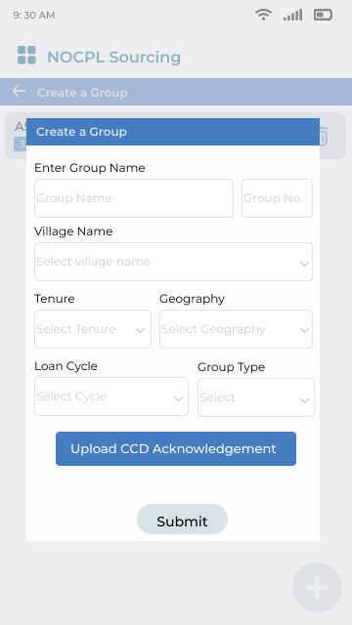
  - Create a Group

- The user first needs to create a group.
- After entering the group name, the village needs to be selected from a pre-populated list of villages assigned to the branch.
- The tenure of the loan, geography (rural/urban/semi-urban), loan cycle, and group type (mother/daughter group) need to be selected from a drop-down list.
- The CCD acknowledgement image then needs to be captured.
- After all the details are filled, the group will be created.

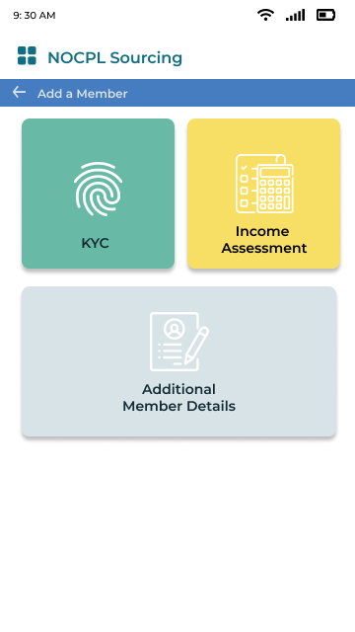
2.0 Add Member
i. The user is directed to the page on the left once he/she clicks on ‘add a member’
The process for adding a member consists of 4 steps. The flow will work like-
- E-KYC
- Income Assessment
- Additional member details

KYC
In this process flow, we are assuming E-KYC is being done for the customer.
- The user first needs to enter the composition of the household-
How many a) Adults b) Children c) Earning members d) Dependent members
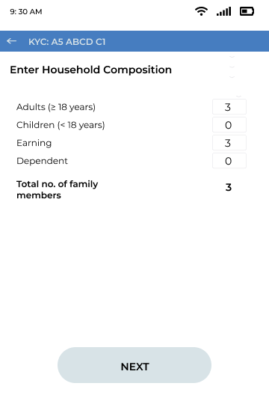

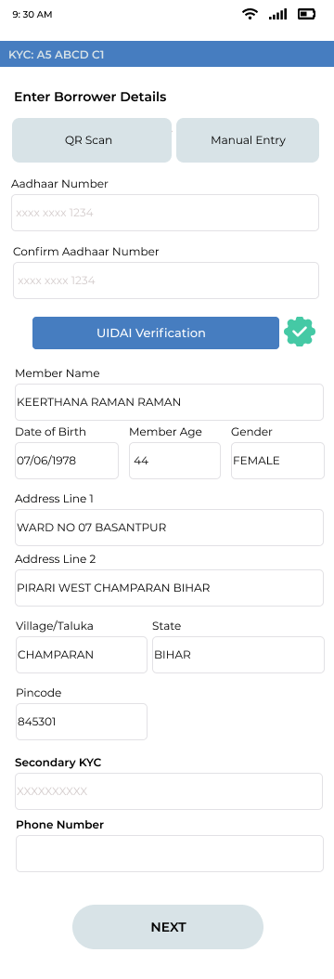
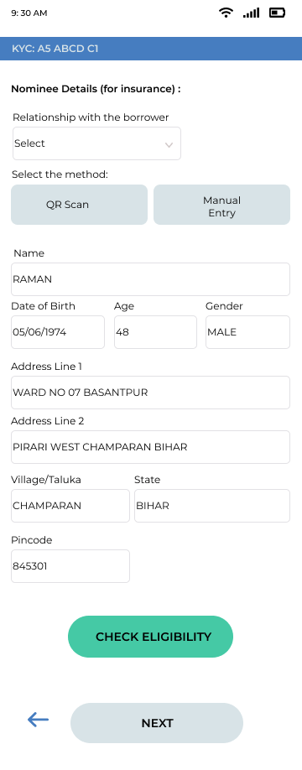
- First, borrowers primary KYC details will need to be authenticated. This will be done by EKYC – Aadhar no. can either be scanned via the QR code option, or manually entered. After the numbers have been entered, UIDAI verification button is to be clicked- for KYC verification.

- Secondary KYC and Phone number of the borrower are entered. Basic nominee details like Name, Address, DOB, Gender can then be scanned via QR/ Manually entered.

- Post this, bureau check will be done for the borrower. If the borrower is eligible, the application moves to the next screen-otherwise- flow ends here.

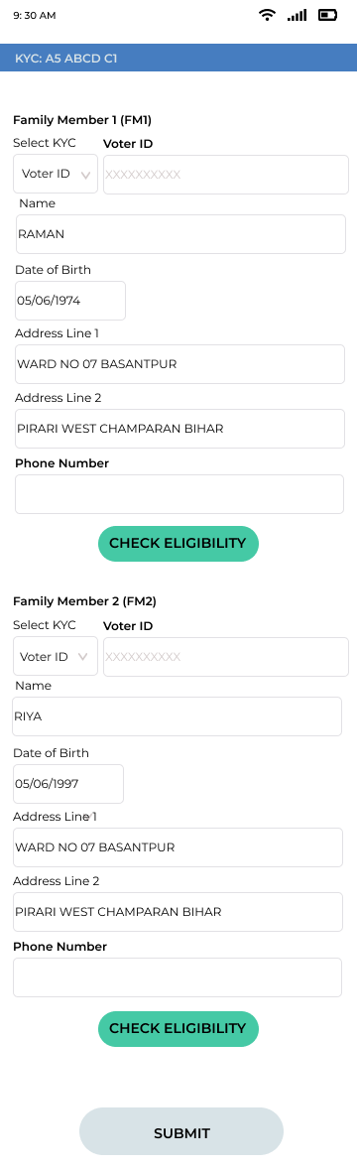
- The field officer now has to enter the following data for other earning members in the family:
- PAN &/or Voter ID
- phone number
- DOB
- Address


- Again, at this stage, a bureau hit will be done for each family member. If the bureau result is ‘reject’ for any of the members, the customer onboarding flow will end then and there.


- Result for each Family member will be displayed as the screens shown above, depending on the result.

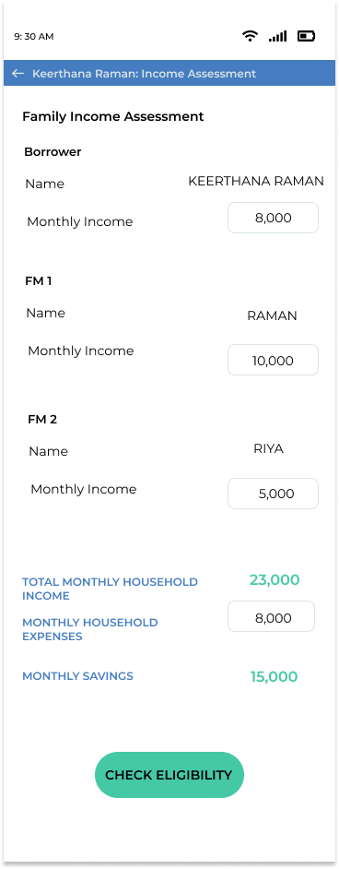
Income Assessment
- The next step is to assess basic cashflow of the house.
- Member wise monthly income is listed
- Household monthly expenses will be entered by the field officer.
- Subsequently, a savings figure will be auto-calculated.
- Once the field officer clicks on ‘check eligibility’- the second bureau hit will be done to determine the final accept/rejection, loan eligibility & tenure.
- If the member is rejected, flow stops here- but if the member is approved- the customer now moves into the ‘additional details’ bucket.

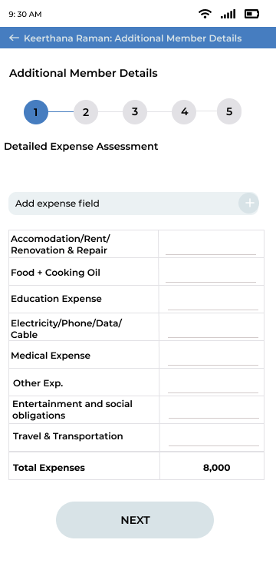
Additional Member Details

In additional member details,
The following needs to be filled-
- Detailed household expense break-up
- Member social details
- Additional Details/Asset Details
- Bank Preference
- Image/Doc upload

Detailed household expenses
- The monthly household expense earlier entered in the income assessment tab will be pre-populated here.
- The field officer will have to give a break-up by expense type.

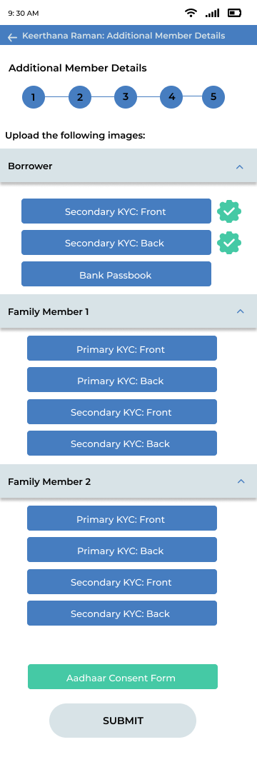
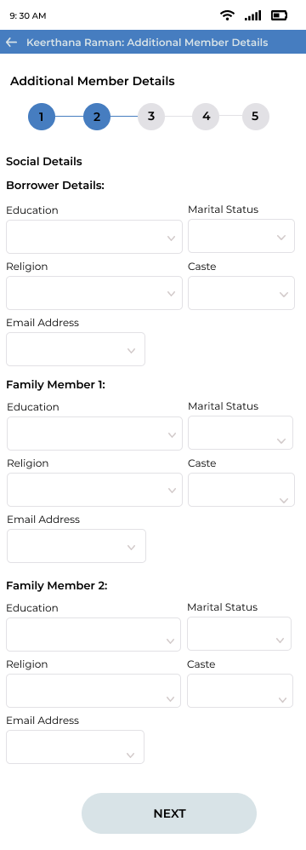
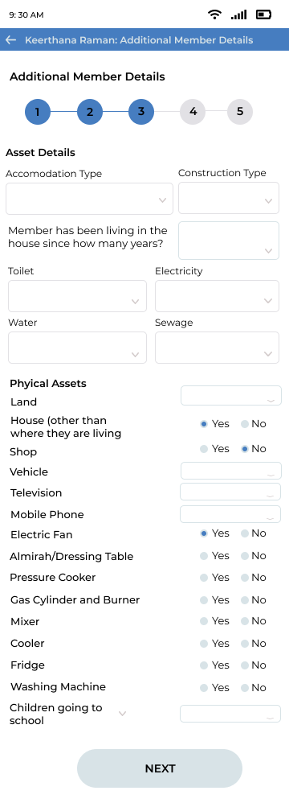
The following will be captured in member social details for all earning members:
- Education
- Marital Status
- Religion
- Caste
- Email Address

Under Asset Details, member accommodation and asset details will be captured.
B | Accommodation
5 | Type | From the list (rent/family/own)
6 | Construction | From the list (kachcha/tin-oof/concrete-roof)
7 | Toilet | N/Y
8 | Electricity | N/Y
9 | Water | N/Y
10 | Sewage | N/Y
C | Physical assets
11 | Land | From the list (n/agriculture/commercial/other)
12 | Shop | N/Y
13 | House (other than where residing) | N/Y
14 | Vehicle | From the list (n/cycle/two-wheeler/three-wheeler/four-wheeler/tractor)
15 | Television | From the list (n/basic/LED)
16 | Mobile phone | From the list (n/basic/smart)
17 | Electric fan | N/Y
18 | Almirah/dressing table | N/Y
19 | Pressure cooker | N/Y
20 | Gas cylinder and burner | N/Y
21 | Mixer | N/Y
22 | Cooler | N/Y
23 | Fridge | N/Y
24 | Washing machine | N/Y
D | Education
28 | Borrower | From the list (illiterate/primary/middle/secondary/graduate/postgraduate)
29 | Earning Family Member-1 | From the list (illiterate/primary/middle/secondary/graduate/postgraduate)
 | Earning Family Member-2
30 | Children going to school/college | From the list (na/n/public/private)

Bank Preference and document upload option will vary from Bank to Bank.
Once these details are entered, the member will move into Monitri for a PD.

