`
EKYC implementation of BC portal

Existing Functionality
Presently BC Channel is using the below process flow for BC Loan sourcing
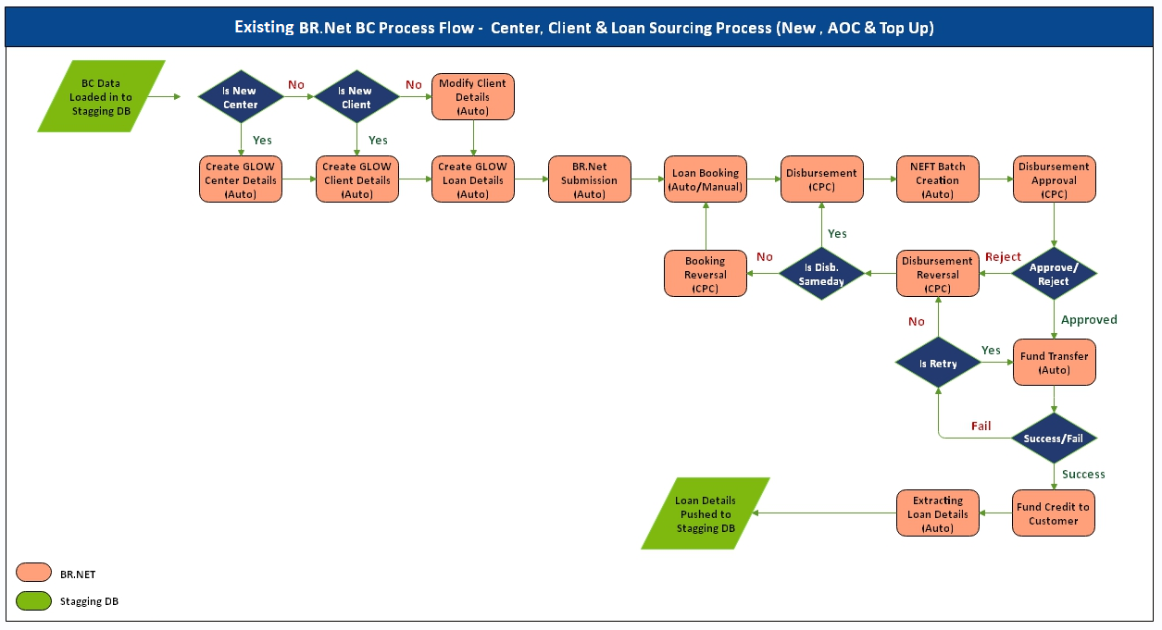

- BC CHANNEL PARTNER is using legacy system to punch loan-processing data. Once all basic check and validations are fine in legacy system, BC CHANNEL PARTNER will download data & uploads through Portal (Center, Client, Image and Loan Details) into the staging DB.
- BR.Net tool picks up the data uploaded by BC CHANNEL PARTNER and performs basic set of validations to check if the uploaded data is as per the defined BR.Net Standards/formats
- If BR.Net Standards/formats/Validations are perfect, corresponding data will be extracted and stored in the respective GLOS Tables. If the Center is existing, system will use same center or it will create new center ID. Secondly, if Client is existing, system will modify details else it will create new Client and attach to the Center.
- BRNET will perform Dedup, AML & CB check
- System will move all the files to CPC Image Verification Activity
- While doing BRNET submission, BRNET will create Loan Application ID
- BRNET will read Booking details from staging and do booking in BRNET system
- On successful completion of Loan Booking activity, Loan Installment Schedule and Loan Documents will be pushed to the staging DB against the Loan Account ID
- On successful completion of Disbursement activity, system will create Center wise NEFT Batch automatically.
- Disbursement Approval activity will be carried out by the CPC team.
- For successful Fund transfer cases, UTR Number will be extracted and inserted into Staging DB

Detailed Requirement

BC CHANNEL PARTNER would like to remove dependency BC customer profile upload activity to make easy sourcing process directly from UIDAI by validating EKYC as per below proposed process flow.
1 2
BC CHANNEL PARTNER (EKYC with fingerprint)
ESB EKYC service
Sarvatra
Wizard and BRNET Integration
IBOSS (EKYC Request for data store) Data linking
Member Detail upload process BC portal

4 3
7 8
5

6 7

BC CHANNEL PARTNER will continue to use their existing legacy system for punching loan process data. First they will capture customer Aadhaar Number and they will call ESFB ekyc API via FingerPrint option. Request will routed through ESFB ESB & Sarvatra to UDAI portal. Response should be saved inside ESFB side as well as BC CHANNEL PARTNER also with unique reference ID. In case if ekyc is success, then BC CHANNEL PARTNER would like to continue data entry process in their legacy system.
- BC CHANNEL PARTNER is using legacy system to punch loan-processing data. Once all basic check and validations are fine in legacy system, BC CHANNEL PARTNER will download data & uploads through Portal (Center, Client, Image and Loan Details) into the staging DB.
- BR.Net tool picks up the data uploaded by BC CHANNEL PARTNER and performs basic set of validations to check if the uploaded data is as per the defined BR.Net Standards/formats
- If BR.Net Standards/formats/Validations are perfect, corresponding data will be extracted and stored in the respective GLOS Tables. If the Center is existing, system will use same center or it will create new center ID. Secondly, if Client is existing, system will modify details else it will create new Client and attach to the Center.
- BRNET will perform Dedup, AML & CB check
- System will move all the files to CPC Image Verification Activity
- While doing BRNET submission, BRNET will create Loan Application ID
- BRNET will read Booking details from staging and do booking in BRNET system
- On successful completion of Loan Booking activity, Loan Installment Schedule and Loan Documents will be pushed to the staging DB against the Loan Account ID
- On successful completion of Disbursement activity, system will create Center wise NEFT Batch automatically.
- Disbursement Approval activity will be carried out by the CPC team.
- For successful Fund transfer cases, UTR Number will be extracted and inserted into Staging DB

Changes in GLOW / BRNET Applications:
- NA
Changes in BC Portal
- Consume API or process the EKYC record
- Accepting Updated Upload process
Changes in BC CHANNEL PARTNER Application:
- Consuming of EKYC API through ESFB Banks ESB API
Action points for ESFB (Exposing new BC channel) :
- eKYC API

ESB/API Changes
- eKYC API

E-KYC ESB services:
On successful completion of EKYC from the third party ,the response of EKYC need to get stored at bank system and the EKYC response need to retrieved from bank IBOSS application through ESB .The following are the input parameter for the retrieving the EKYC response

Request from IBOSS
- Channel ID third part channel ID
- RRN Retrieval reference number
- Local_Trans_Time
- Stan
- CA_Tid Response received from ESB
- CA_ID Response received from ESB
- CA_TA
Response from ESB
- RRN
- Stan
- Local_Trans_Time
- ResponseCode
- ResponseMsg
- KycResponse
- Resp
- TransactionInfo
In the above valid the encrypted response to be decrypted at IBOSS end through the private certificate and for capturing the customer demographic data

Data Migration
- Need to manage both new format of upload with customer data and New format
- Getting and process the data with ESB EKYC response

Risks and Mitigations
- Since sensitive data of customer to getting migrated in API’s all the API should be in secured layer and encrypted
- Other Upload process need to follow same process as per existing flow expect EKYC leg

