Mobile Application:
CIMS:
Mother Daughter Group:
In CIMS Mobile application:
- On sourcing time RO select Daughter group ‘YES’, Ensure the current sourcing location of members and click confirm.
- Enter the mother centre unique code and click search.
- If the entered Mother center is of around 1000m from the current sourcing location, it will be shown
- Select the mother center and click ‘Confirm’
- Click ‘Locate Mother Group’ option to find the mother group location from the current sourcing location

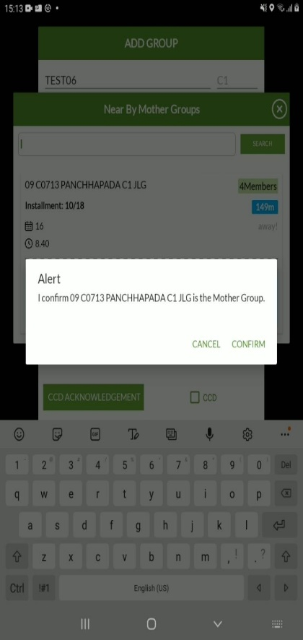
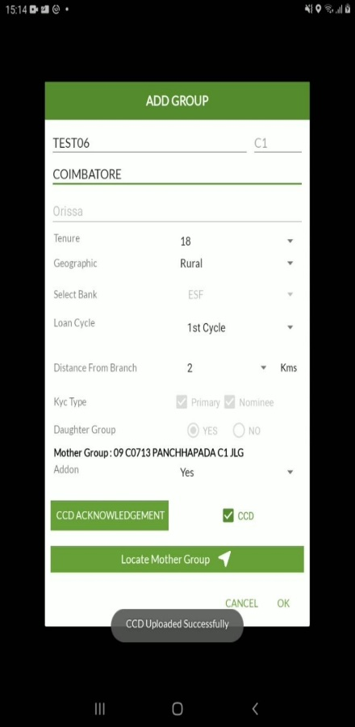
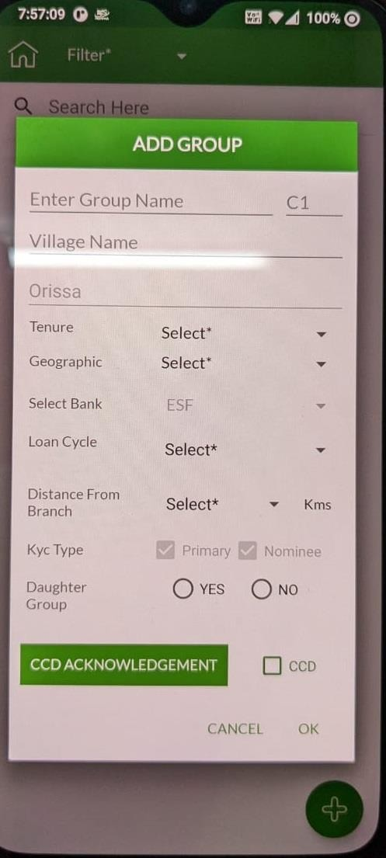
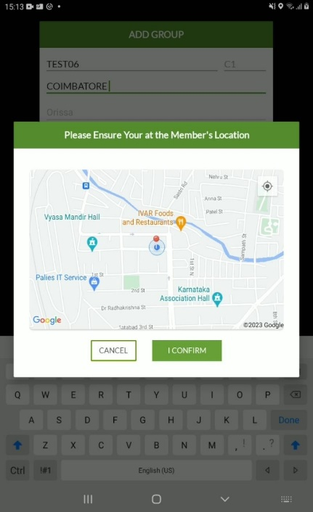
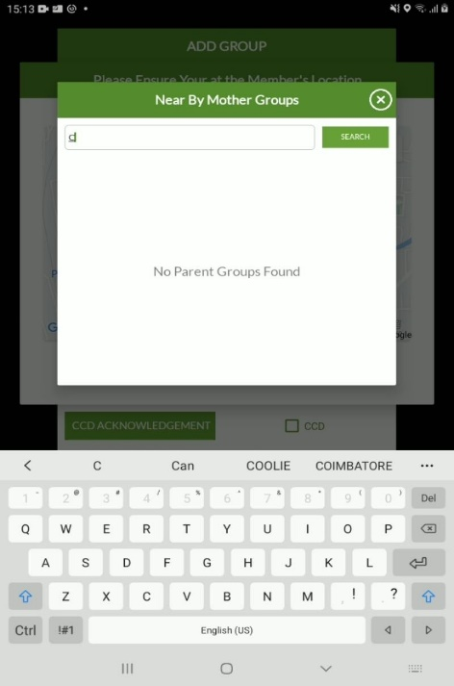
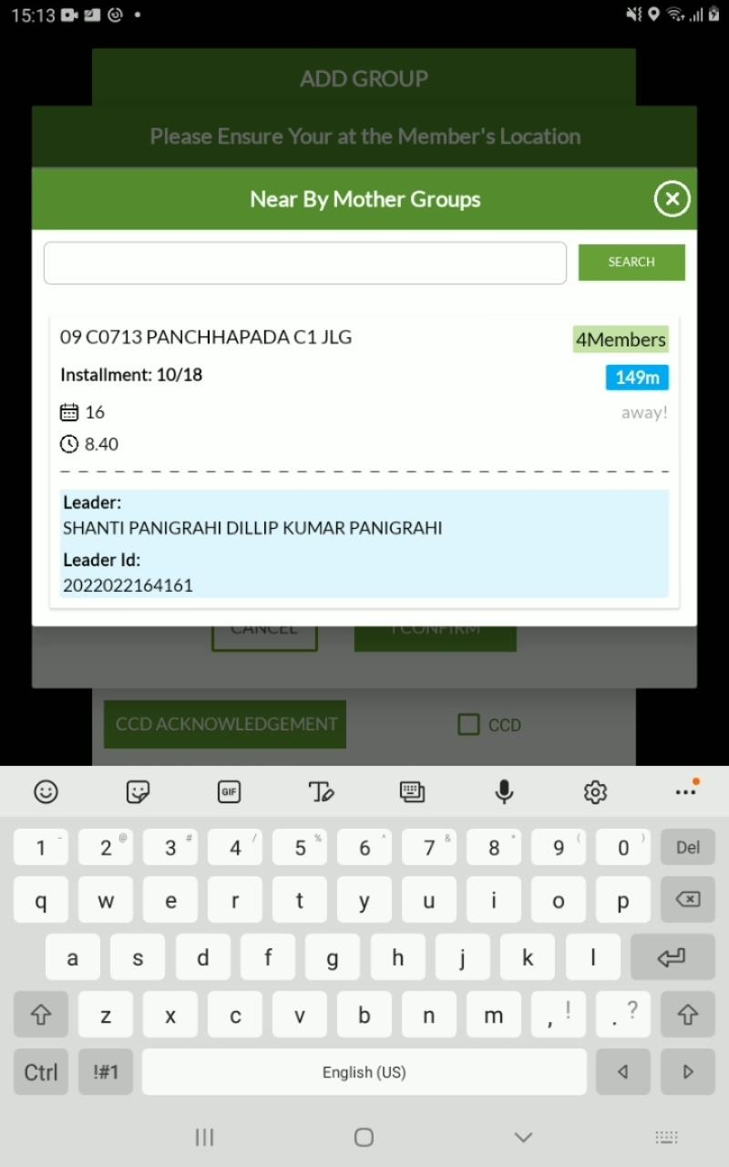

 | 1st Cycle |  | 1st Cycle |  | 2nd Cycle |  | Partial
 | Daughter Group |  | Daughter Group |  | Daughter Group |  | Daughter Group
 | No |  | Yes |  | Yes - Default |  | Yes - Default
 |  |  | Addon |  | Top- Up |  | Top- Up |  | To be removed
 |  |  | No | Yes | No | Yes | No | Yes
 |  |  | Staging Server | Manual Dump | Manual Dump | Manual Dump | Manual Dump
 |  |  | EMI Validation
 |  |  | Geo Location Restriction
 |  |  | Ro ID Validation

In Monitri_Mobile Application :
- In Monitri mobile application- user must be able to see the center meeting place of the mother group/ location of the mother group/ sourcing photo of center leader and the center leader’s phone number.
- User does not select a meeting place for the daughter group, since the meeting place will be the location of the mother group.
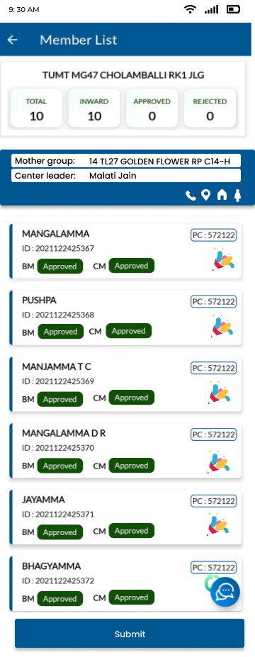

Web:

- Credit officer will be able to see the distance between the new member’s location with the mother groups meeting place.
- Credit officer also needs to confirm this addition with the mother groups leader (in mother groups members page- button labelled ‘Consent taken for Hybrid Group’. If these is selected, should reflect in group page UI (Green dot. Logic is- this button should be selected for AT LEAST1 member from the mother group.
- No center meeting selection needed here. Center meeting is mother group’s center meeting place.
- Group submission will be as usual.

