SOURCING PROCESS THROUGH E-KYC MODEL

Process flow
Step 1: Download Secu Gen RD Services App

Step 2: Download and Install the SO App

Step 3: Capturing the EKYC of the Applicant

SCREEN SHOTS OF DEVICE AND ACTIVATION PROCESS
Step 1: Download Secu Gen RD Services App
Download Secu Gen RD Services App from Google Play Store.
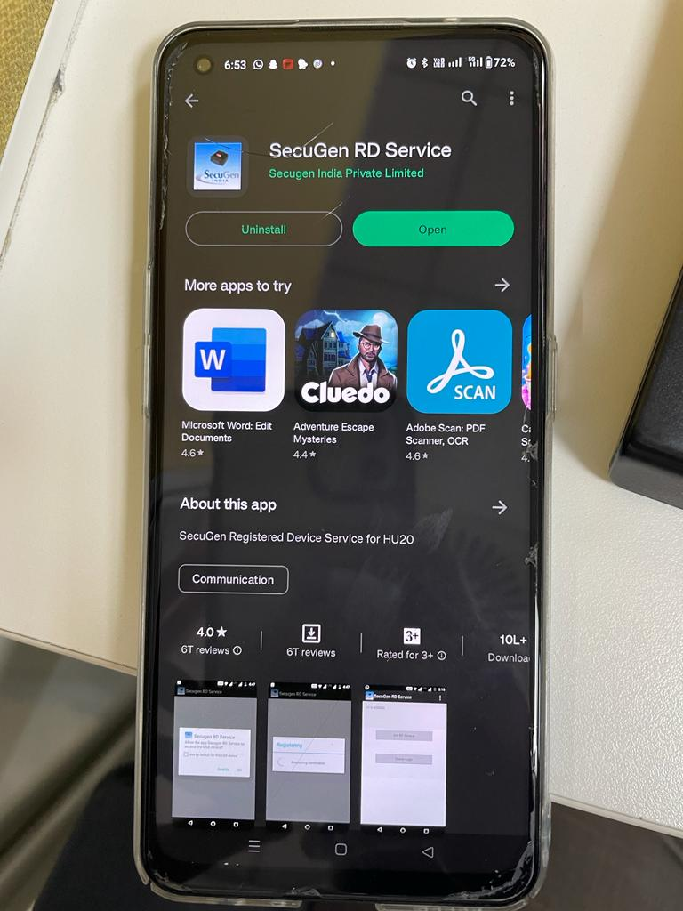
Click Activate: 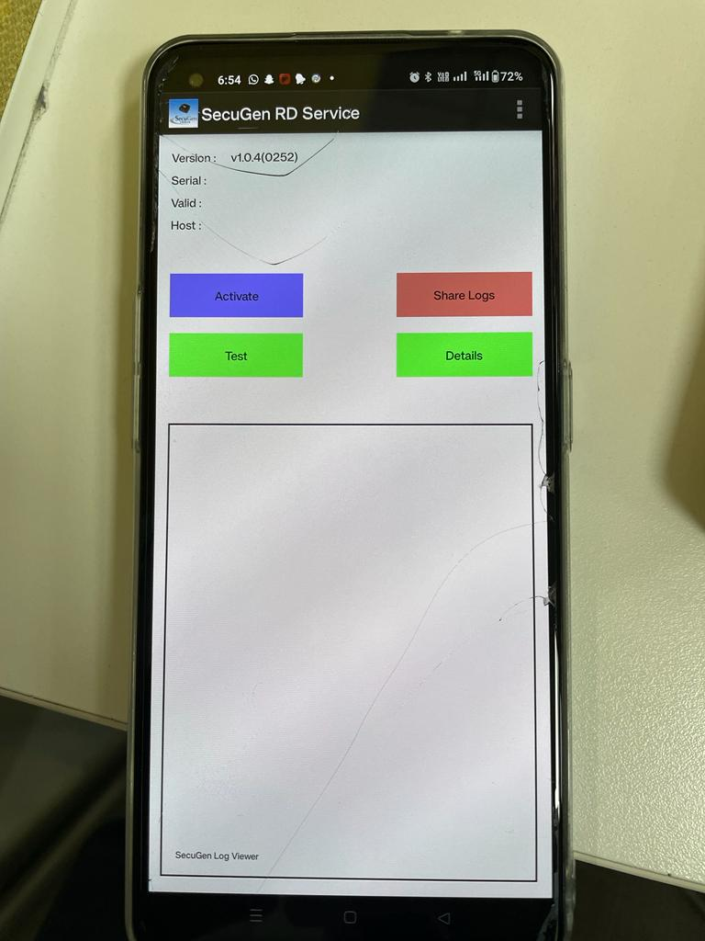
Alllow all permissions: 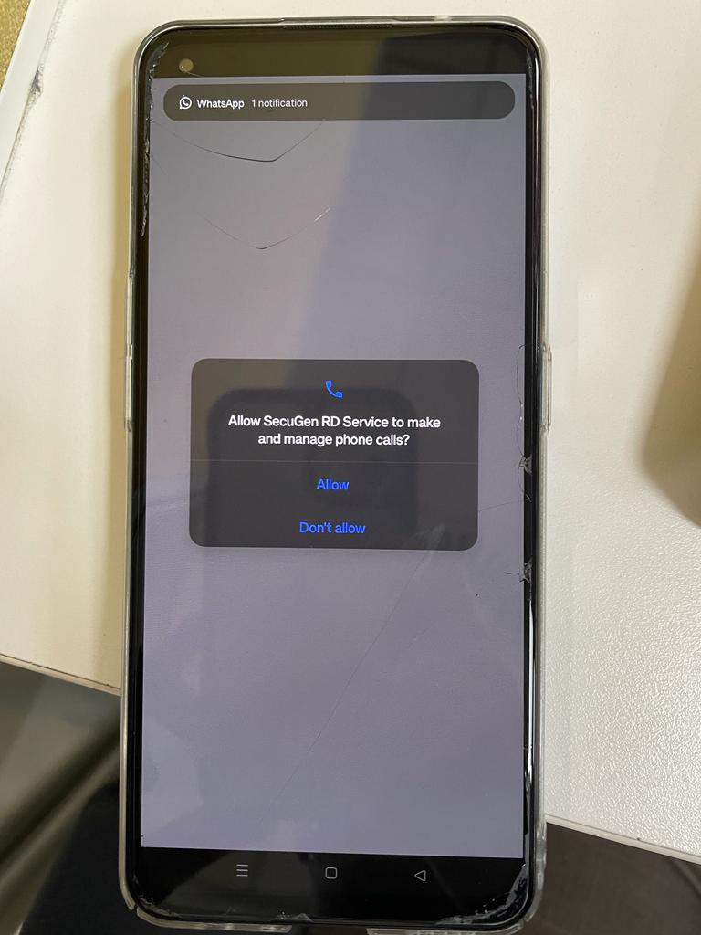

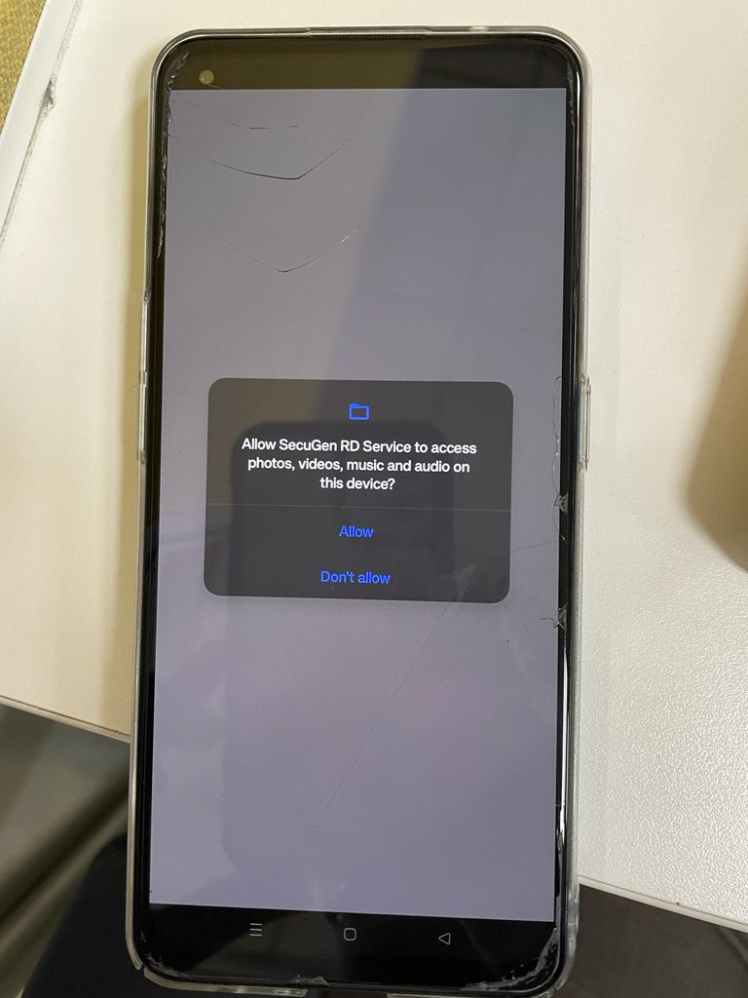
Step 2: Download and Install the SO App
Download and Install the SO App through the following link:
https://install.appcenter.ms/users/cflindia.analysis/apps/salesone/distribution_groups/uat%20%2f%20preprod
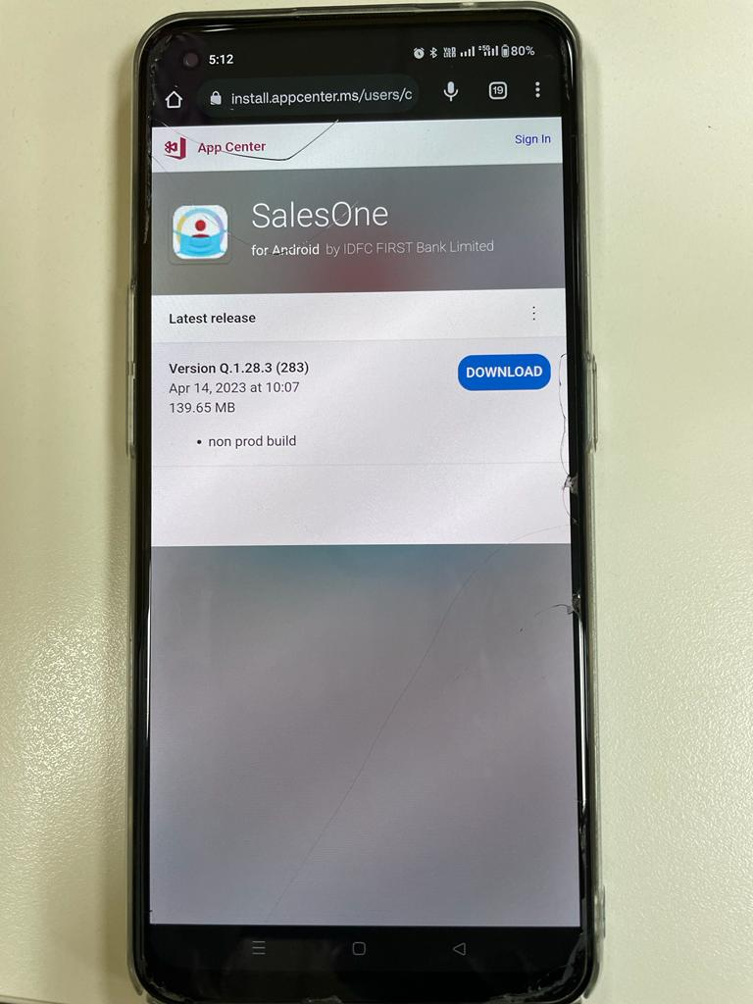
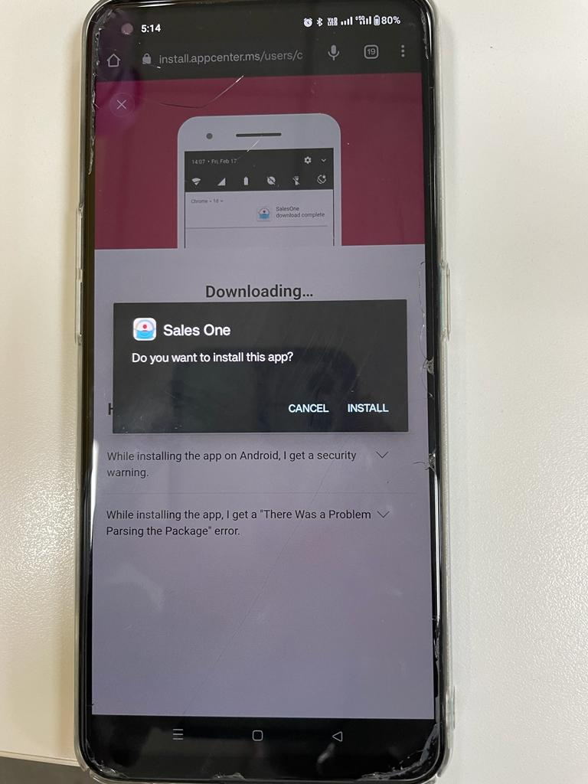
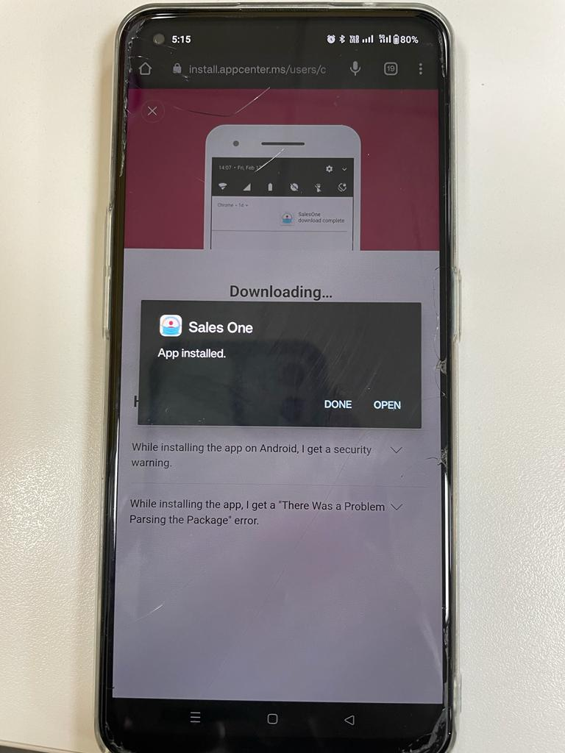
After opening the App, click on OK: 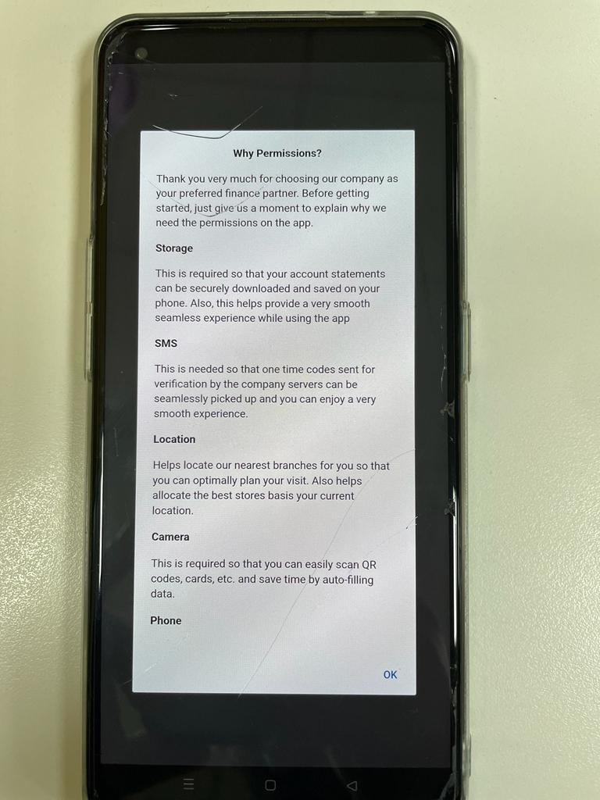
Allow All Permissions: 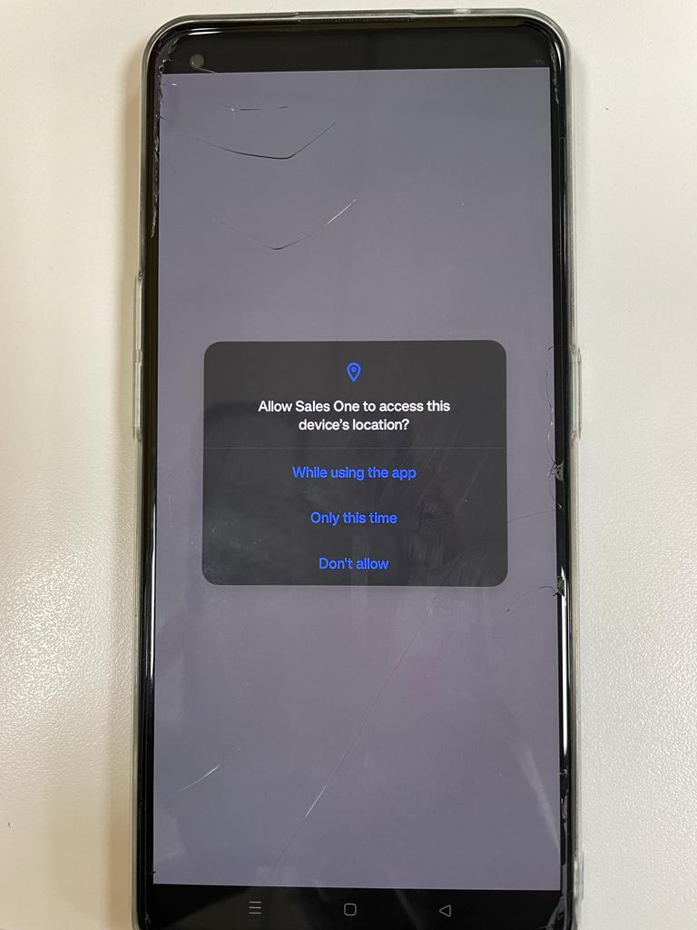

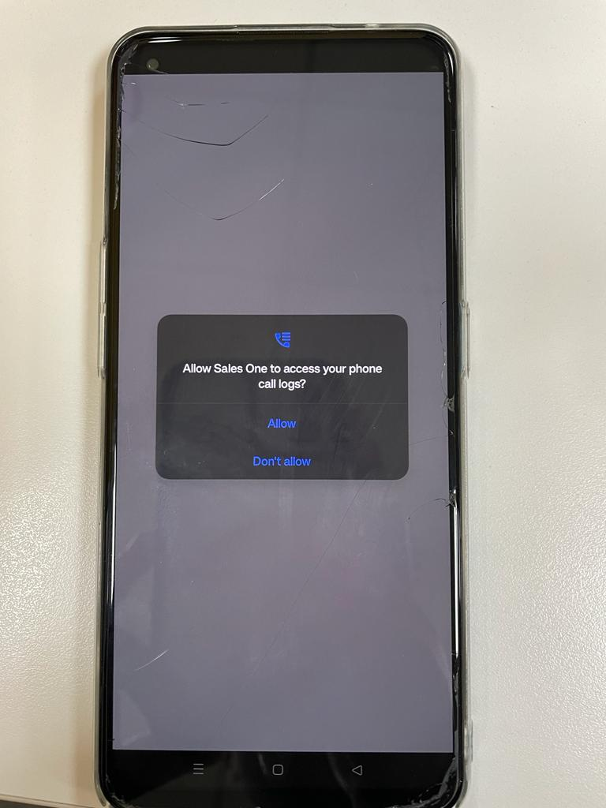
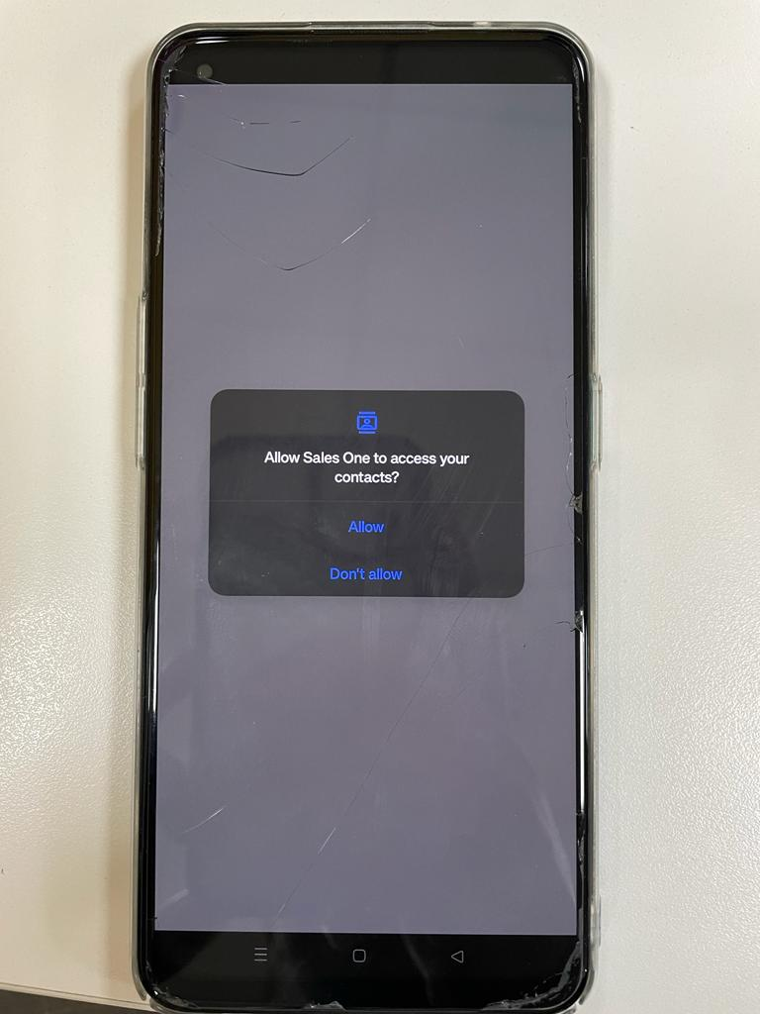
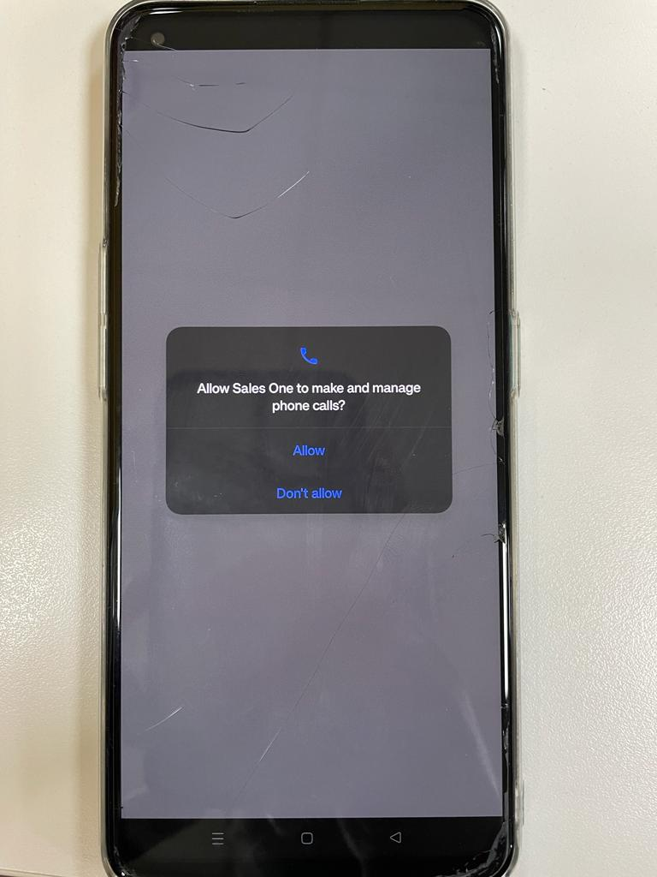
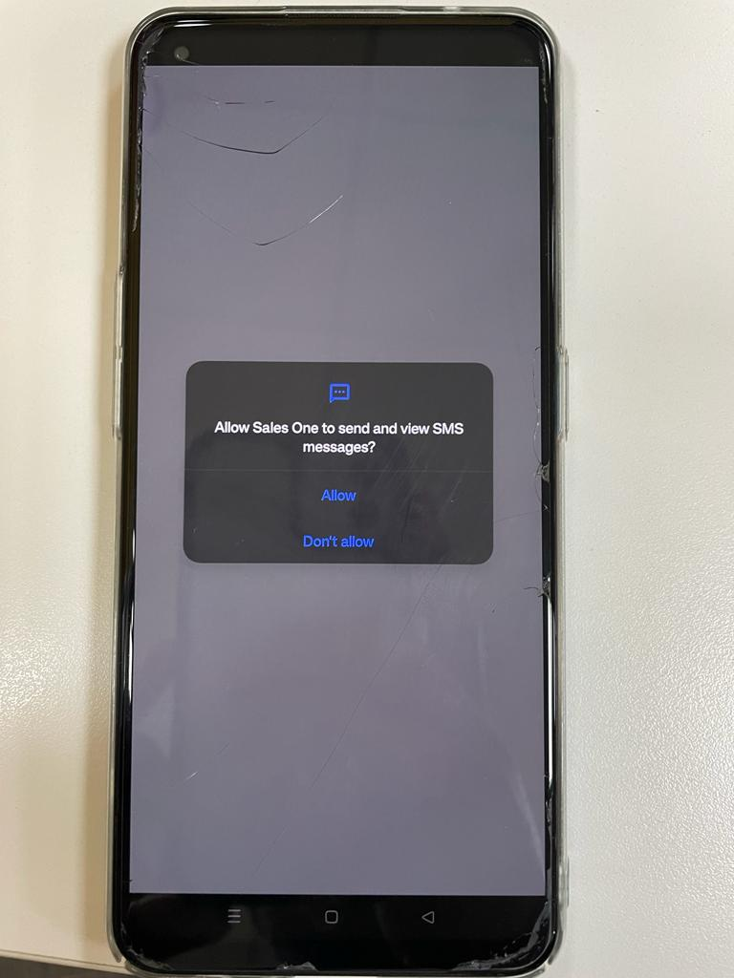
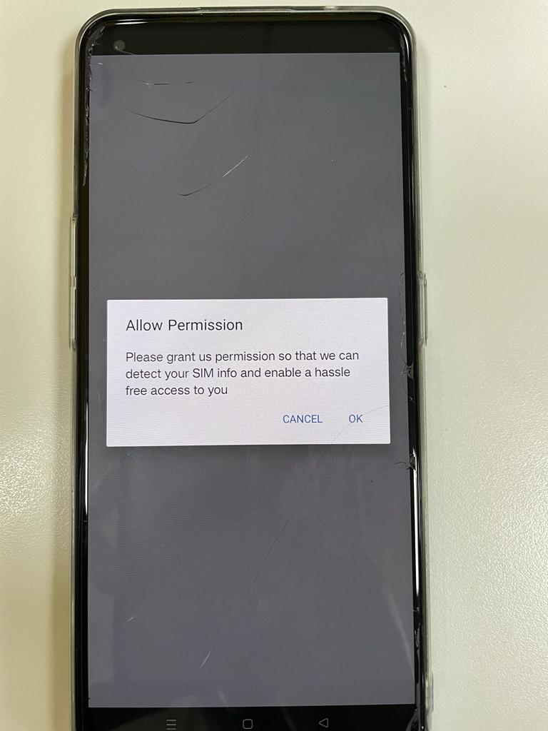

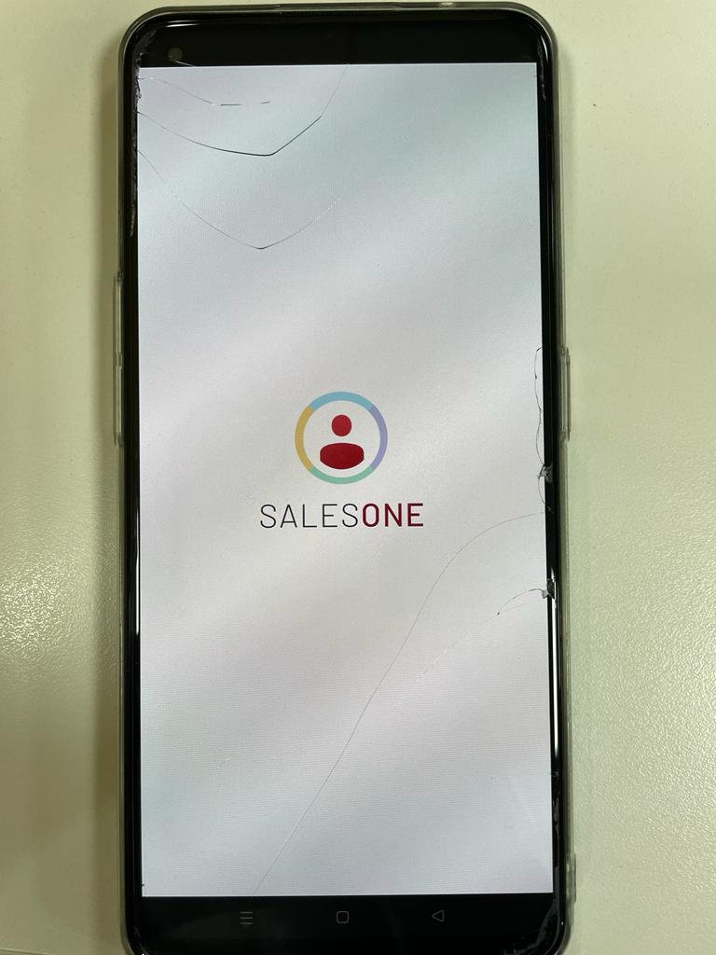
Click on Rural: 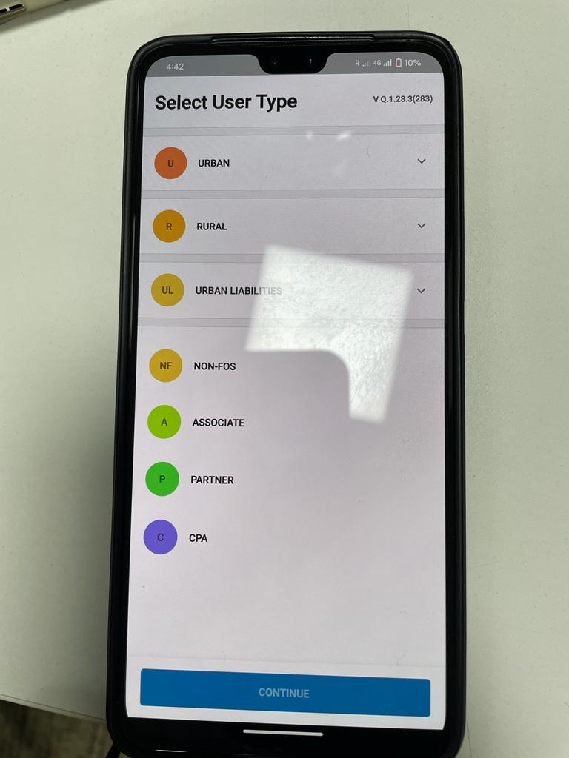
Click on Rural Sales Officer: 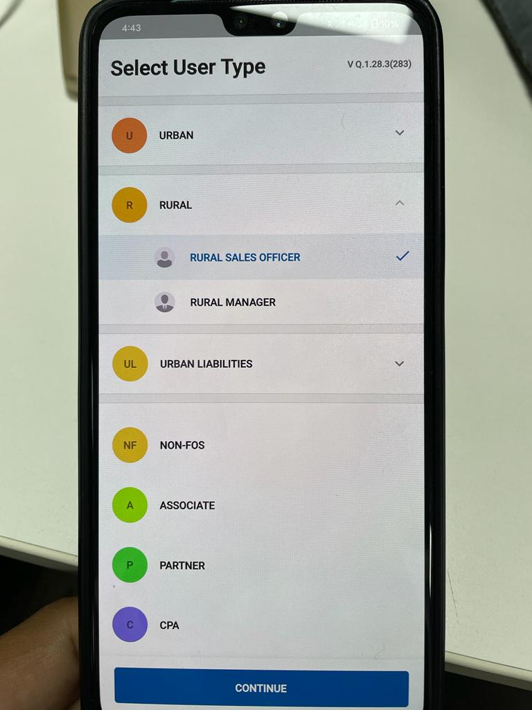
Click on BC Partner: 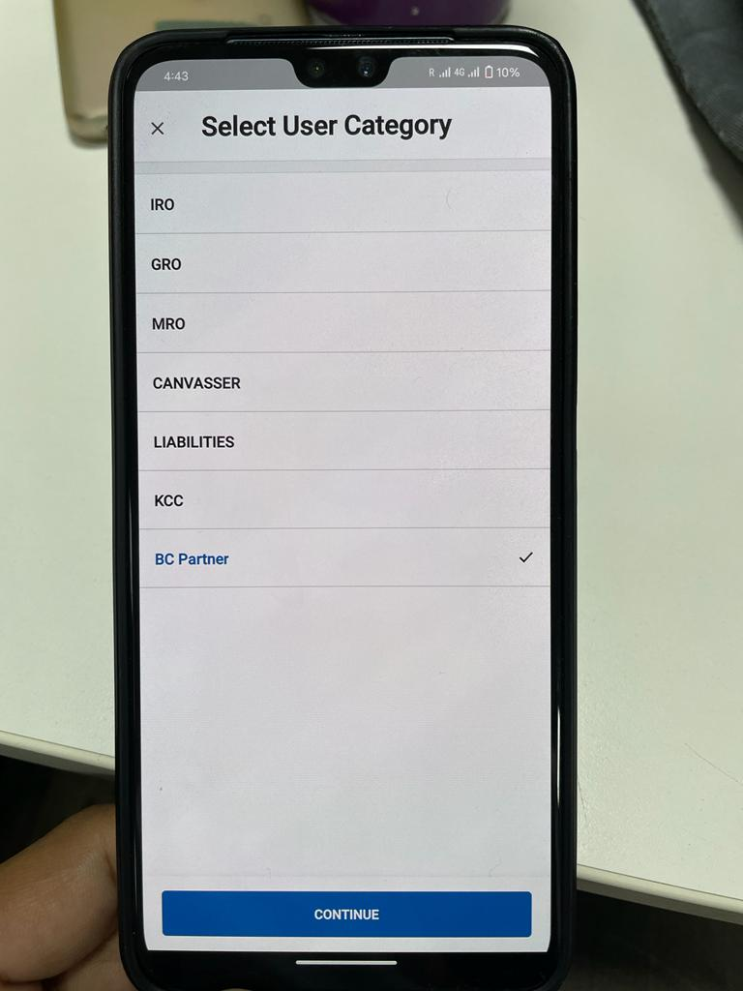
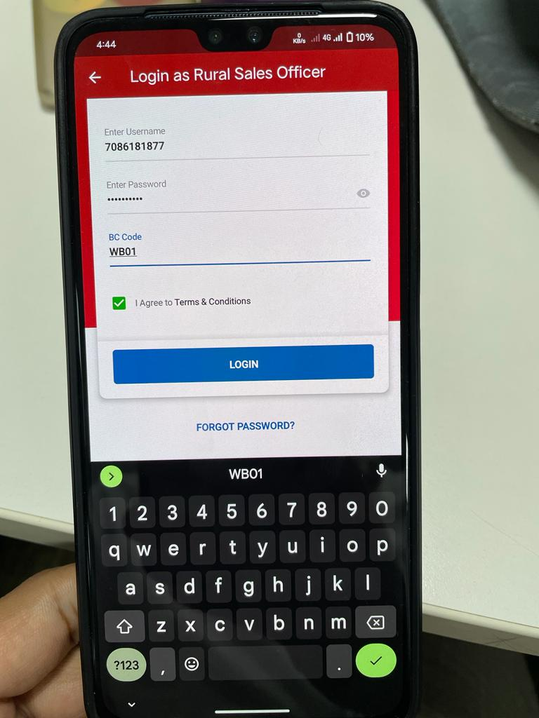
Enter User Login Credentials:
USERID : RO MOBILE NUMBER MAPPED WITH BANK
PASSWORD AS GIVEN BY BANK .
BC CODE : MH04
Click on BC: 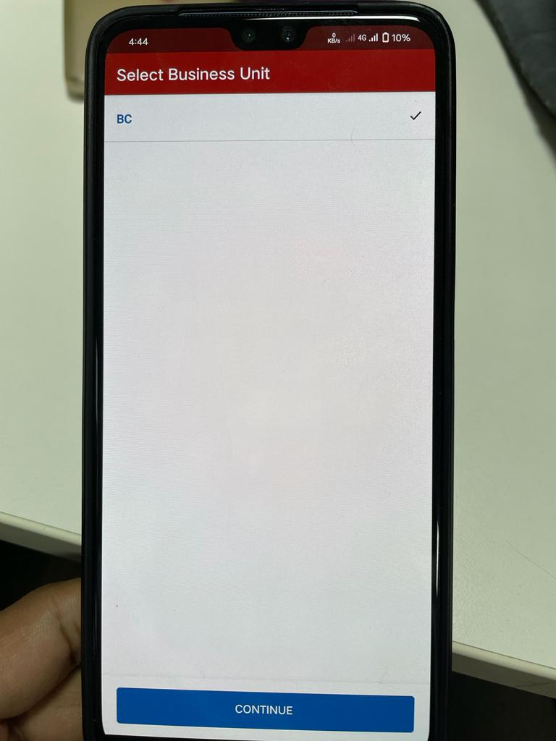

Step 3: Capturing the EKYC of the Applicant
Capture Mobile Number Owned by Member and DOB of Member
(Note: same mobile number to be entered during data entry.Else Bank will reject this Member if any Duplication Found)
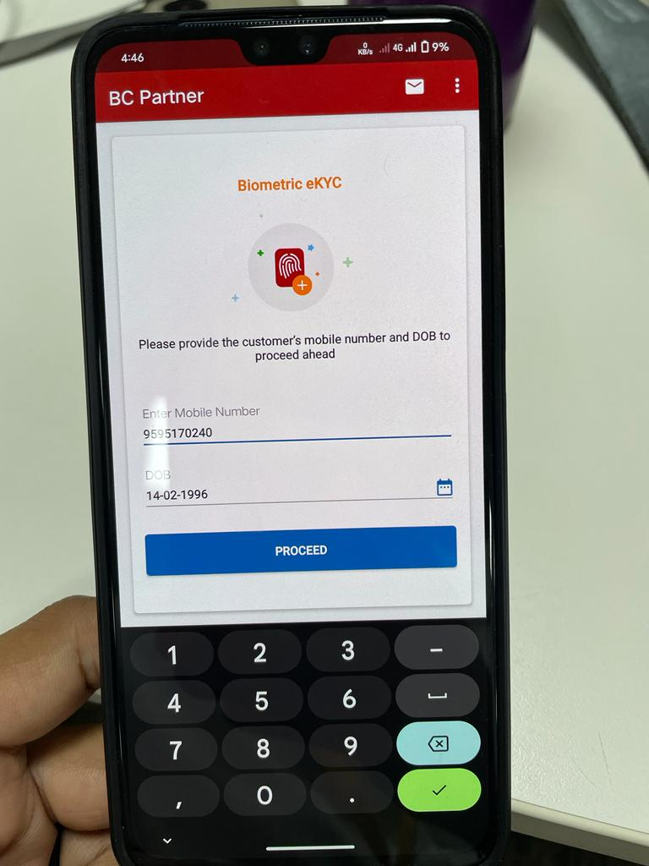
Enter OTP received by the Applicant: 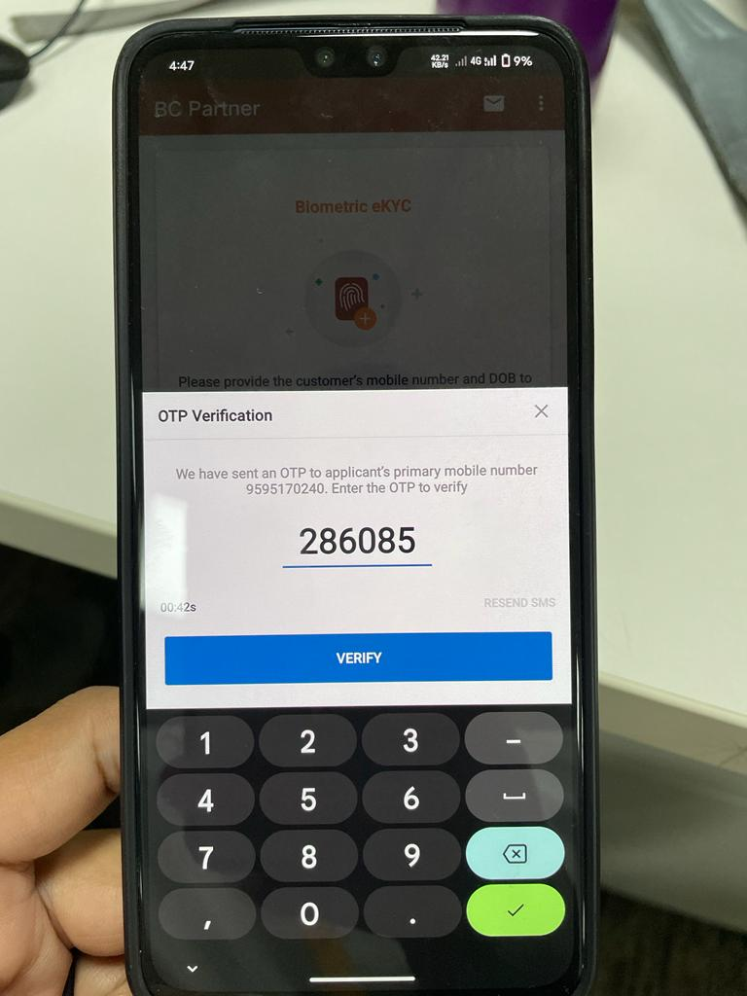
Ask consent of the Applicant and tick on both the tick box: 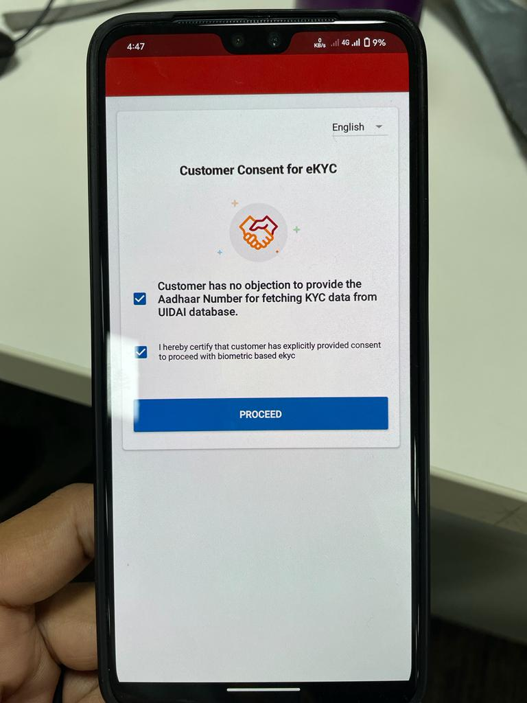

Enter Aadhar of the Applicant: 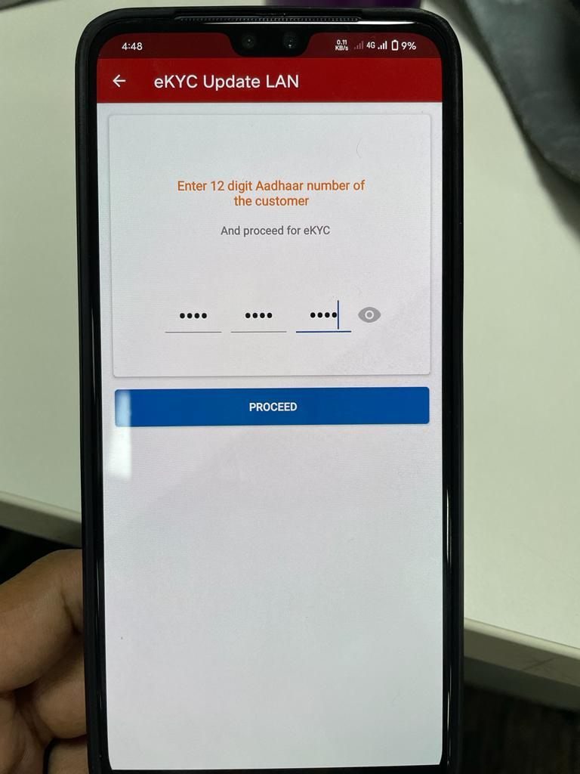
Select Secugen option: 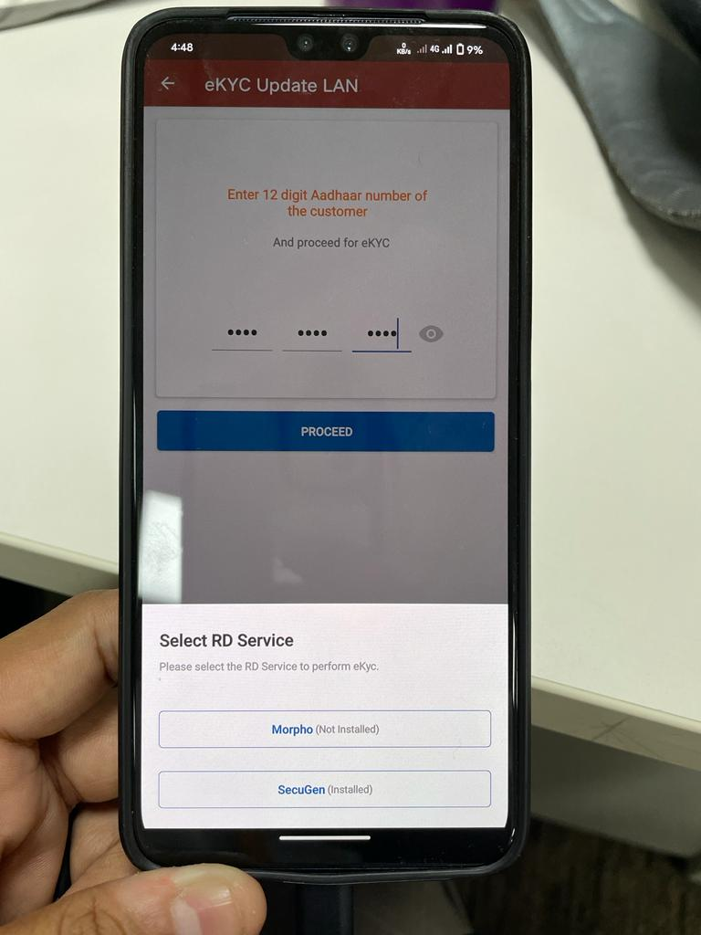

ENABLE OTG CONNECTION IN THE MOBILE DEVICE AND CONNECT EKYC DEVICE WITH MOBILE

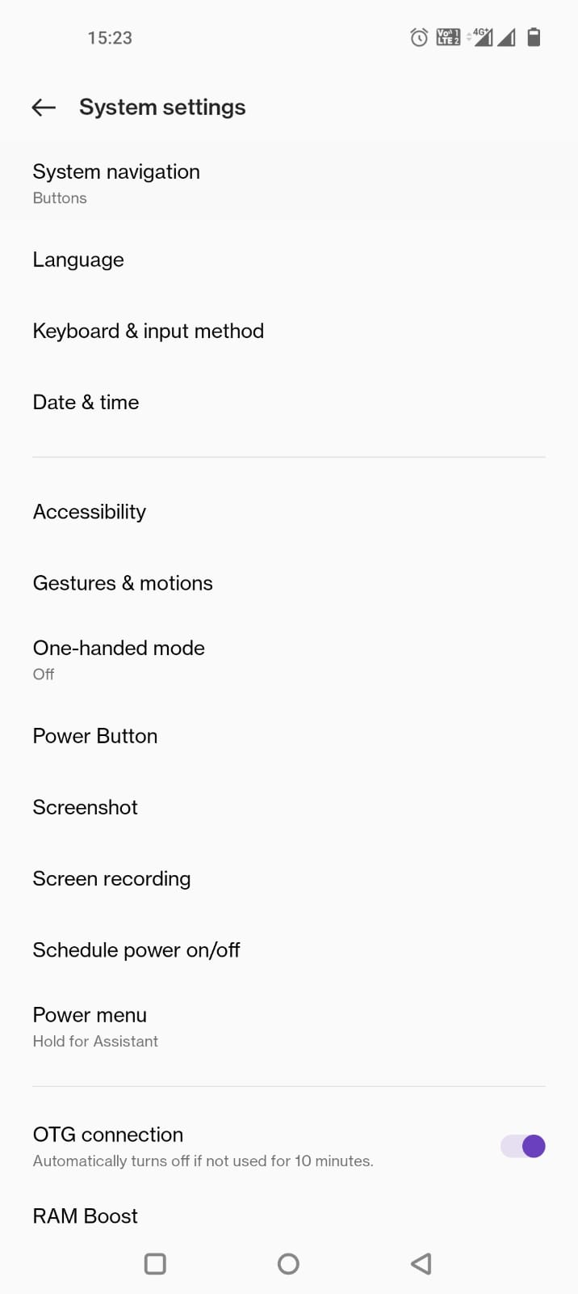

Obtain applicants fingerprint: 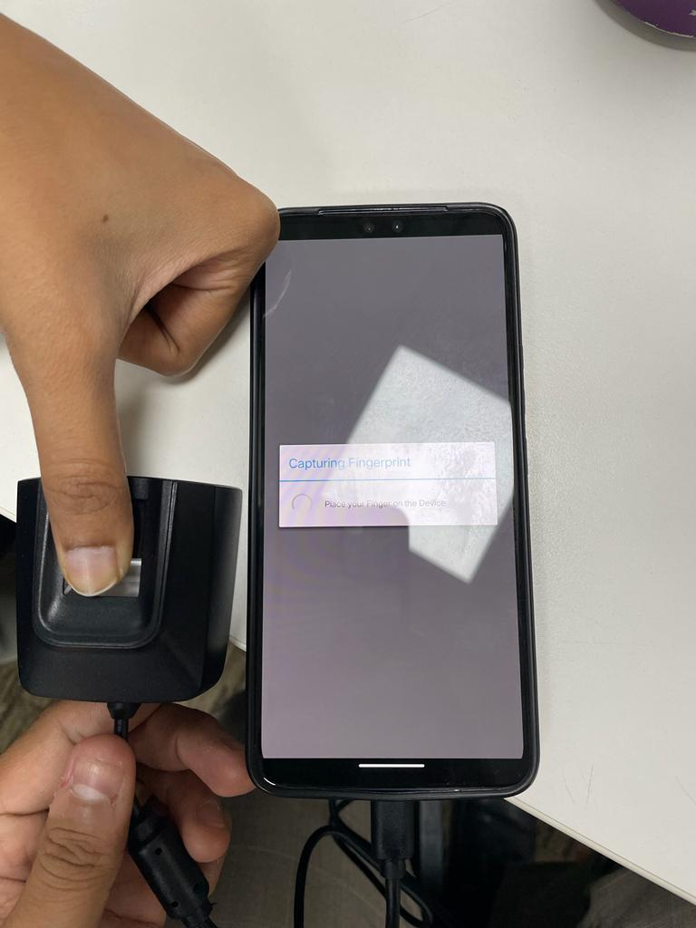
Click on Send for EKYC: 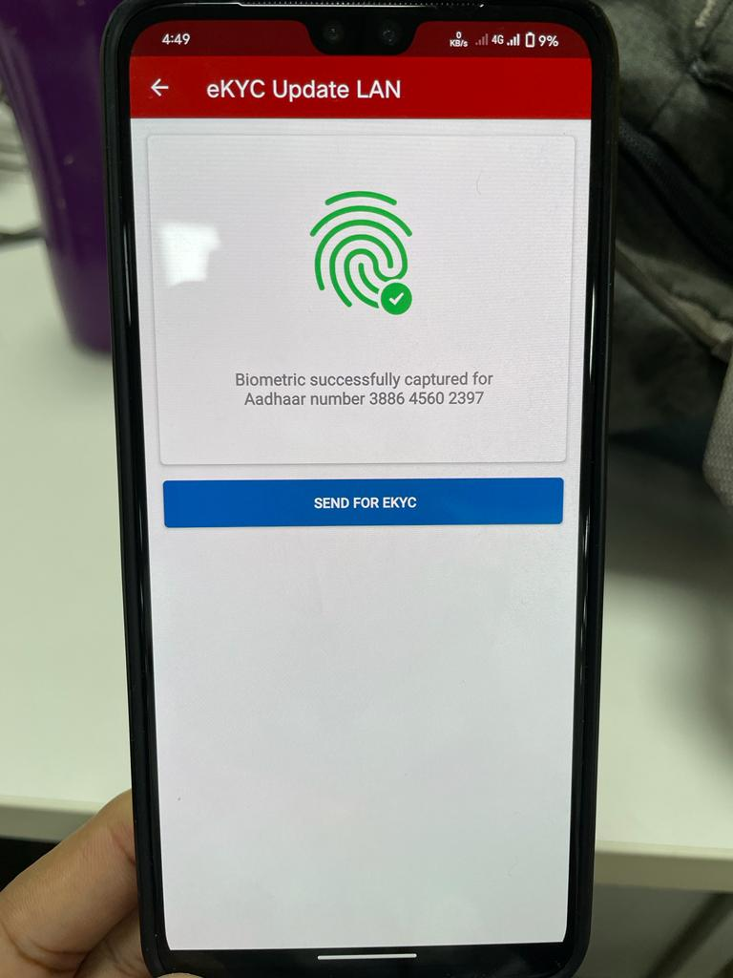
Once EKYC Success Click “OK” to Complete Process 