

Approach Document for AUTOMATED SANCTION PROCESS and Mandate field

Document Version Control
Name of Document – Requirement for Loan sanction process through system no manual intervention required at SSFB for production 4200.
Version |  |  | 1.0
Document Definition |  |  | Business Required Document
Author |  | Yogesh Sharma
Reviewed By |  | Gyanendra Bajpai
Approved by
Version No. | Revision Discerption | Date | Author | Reviewer | Approver
1.0 | Original | 13-06-2022 | Yogesh Sharma
2.0
3.0
4.0
5.0

  - . Context
Currently we are working with NOCPL in a BC partnership in MP and western UP, In March 2022 we have successfully launched the product of JLG TL with our BC partner NOCPL with a disbursement amount of Rs 31 Cr in 7 months. Apart from NOCPL we are looking other partnership too like Arohan in Rajasthan, and some other are at very initial stages of discussions. In this context of partnership and as per our requirement we need to automate the process of sanctioning at our end and also introduce the mandatory fields of data which cannot be blank as well as introduction of data intelligence.
  - . Business Use Case
Automated of Sanctioning process is required for the below reasons
- It is an estimate for 5 Cr disbursement it required 1 Credit officer to sanction the loans. So through Automated process we save the cost for our bank.
- Due to the Manual process the sanctioning the members may delay up to 2 days for the disbursement since if flows will increase it take time to clear at Manual level by Credit officer.

  - Functional Requirement for 4002
Below are the requirement for change in technical and functional.
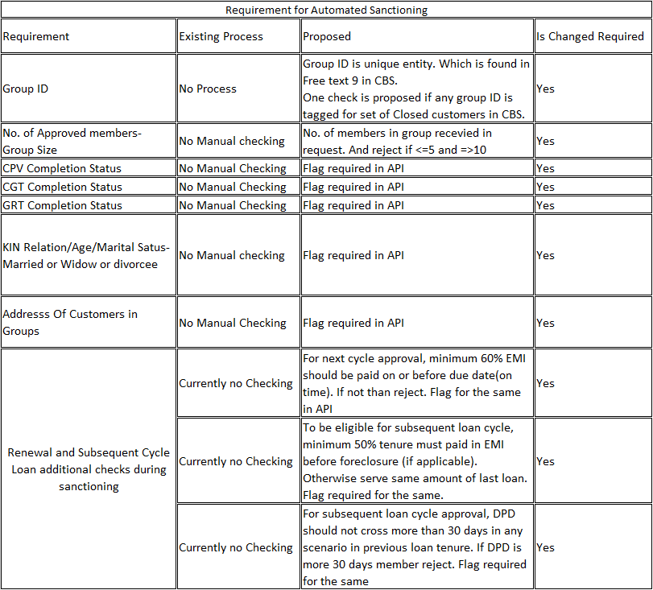
Technical Requirement:

A new functionality to be introduced in our system for automate the process of sanctioning by which TAT will be reduced and also reduce the operational cost of our product.

Error! Hyperlink reference not valid.

Explanation of Requirement:

Minimum Group Size “5”
Maximum Group Size “10”
CGT Status : Give what required from BC – Take declaration from BC CGT has been conducted and pass.
CPV Completion Status: Give what required from BC – Take declaration from BC CPV has been conducted and pass
GRT Status: Give what required from BC – Take declaration from BC GRT has been conducted and pass

KIN Relation – In the consist of group no member are related to each other in Kin relations.
Age of Customer – Customer age at the time of any Cycle loan is not more than 58 and not less than 18 years. Take decleration from BC on the correct age criteria of the group.
Marital status – No customer in the group is unmarried.

Documentation required.

For that one document generated and share with disburse docs where all the confirmation should be there.

- CPV Completion Status – With date and time and Name and emp code of person done
- CGT Completion Status- With date and time and Name and emp code of person done
- GRT Completion Status- With date and time and Name and Emp code of person done
- KIN Relation/Age/Marital Status- Married or Widow or divorcee – Confirmation required with person name and emp code. Who check the widow age.
- Address Of Customers in Groups – Declared by BC that all customer of the group is resident of Same locality.
- For next cycle approval, minimum 60% EMI should be paid on or before due date(on time). Declaration required from BC partner.
- To be eligible for subsequent loan cycle, minimum 50% tenure must paid in EMI before foreclosure (if applicable). Otherwise serve same amount of last loan. Declaration required from BC partner.
- For subsequent loan cycle approval, DPD should not cross more than 30 days in any scenario in previous loan tenure. Declaration required from BC partner.

